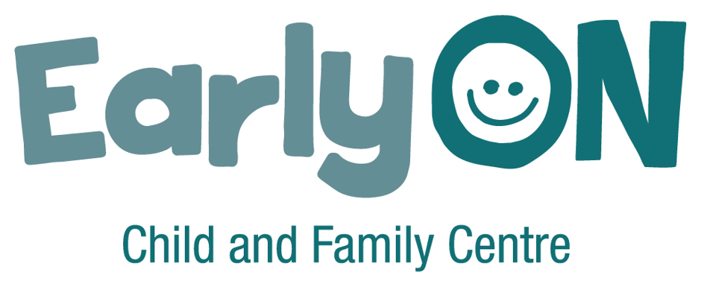

EarlyON onboarding checklist
The onboarding checklist for staff in EarlyON settings includes the following sections:
- Administrative – collect information and documents
- Orientation to the centre, program, and role
- Training
- Set up personnel file for staff
- Supporting materials to be provided
- Orientation to the overall early years and child care system in Peel

Administrative – collect information and documents
Item | Date received/ completed
Signed employee letter (staff)
Resume with references (staff)
Medical form (staff)
Health check (students)
First Aid/CPR card (staff)
Criminal reference check, vulnerable sector check (all)
Education certificate (staff)
College of Early Childhood Educators registration certificate or other professional association verification (if required - staff)
Complete Employee Personal Information form (staff)
Complete Notice with Respect to the Collection of Personal Information form (all)
Void cheque or account information for Payroll (staff)
Other:
Other:

Orientation to the centre, program, and role
Topic | Format (online, in person, hard copy) | Responsibility (self, supervisor, other) | Date completed
Introduction to EarlyON centres in Peel | Online resource – see EarlyON onboarding page:  peelregion.ca/business/early-years-child-care-providers/onboarding-new-employees/earlyon-onboarding
Introduce new hire to your EarlyON organization and/or centre
Tour of the centre – including fire and emergency evacuation plan, location of exits, staff washrooms, staff room, storage of personal belongings, and allergy postings (as required)
Introduce new hire to other staff (including centre staff, other non-EarlyON agency staff and school staff, where applicable) and their roles
Introduce new hire by email to organization or other relevant organizations (as required)
Review centre policies, procedures, and processes with new hire
Provide employee handbook, schedule time for new hire to read, and follow up to answer any questions
Introduce new hire to Peel’s EarlyON Continuous Quality Improvement (CQI) approach | Find the Continuous Quality Improvement presentation at: peelregion.ca/business/early-years-child-care-providers/onboarding-new-employees/earlyon-onboarding
Orientation to daily operations
Orientation to specific duties and responsibilities associated with the role
Review documentation needed
Provide information about support available within the centre (who to go to for different concerns and questions)
EarlyON staff spotlight video | Find the videos at:  peelregion.ca/business/early-years-child-care-providers/onboarding-new-employees/earlyon-onboarding
Other:
Other:

Training
Topic | Format (online, in person, hard copy) | Responsibility (self, supervisor, other) | Date completed
Orientation to training technology/learning management system
Connections to “How Does Learning Happen?” | “How Does Learning Happen?”:  ontario.ca/page/how-does-learning-happen-ontarios-pedagogy-early-years
Anaphylaxis training, review anaphylaxis emergency plans, signature on all EpiPen training | Online training:  allergyaware.ca/courses- (scroll down to Anaphylaxis in Child Care Settings)
Health & safety course | Online training: labour.gov.on.ca/english/hs/elearn/worker/foursteps.php
WHMIS
AODA
Ontario Child Care Management System (OCCMS) (if needed)
Communication and collaboration practice guideline | Online resource: See the resources page on the College of Early Childhood Educators website: college-ece.ca/members/resources/
Professionalism practice guideline | Online resource: See theresources page on the College of Early Childhood Educators website: college-ece.ca/members/resources/
Overview of Child Development Supports | Online resource available at: peelregion.ca/business/early-years-child-care-providers/onboarding-new-employees/earlyon-onboarding
Other:
Other:

Set up personnel file for staff
Item | Responsibility | Date completed
Set up staff profile in provider payroll system
Set up staff profile in CDRCP
Set up staff profile on email group/phone
Other:
Other:
Other:

Provide supporting materials
Item | Format (link, hard copy, etc.) | Date provided
Policy and procedure manual
Peel Region EarlyON Child and Family Centres business practices and funding guideline | peelregion.ca/children/operators-and-partners/funding-resources/#earlyon
Training handbook/manual (if applicable)
Human Resources manual/employee handbook
Program calendar
Door entry code or other security items
Business card (if applicable)
Payroll and scheduling information
Other:
Other:
Other:
Other:

Orientation to the overall early years and child care system in Peel
These resources also provide information about the overall early years and child care system in Peel. Choose resources from the list to help you onboard your new staff.
You can find these resources at: peelregion.ca/business/early-years-child-care-providers/onboarding-new-employees/earlyon-onboarding
System resources | Brief description
Peel’s early years and child care sector | This resource is an overview of the early years and child care sector in Peel, including Peel Region’s role as the service system manager.
Early Years and Child Care Service System Plan | The Early Years and Child Care Service System Plan sets the path for how we will continue to build and grow an early years and child care system that is responsive to the current and future needs of children and families in Peel.
Journey Together program | This resource describes the Journey Together program.
Our intentional journey of growth: enhancing diversity, equity, and inclusion in Peel’s EarlyON system | The “Our intentional journey of growth: enhancing diversity, equity, and inclusion in Peel’s EarlyON system” report highlights the key steps Peel Region and EarlyON providers are taking to enhance diversity, equity, and inclusion in EarlyON across Peel.
CDRCP professional learning | This resource describes CDRCP’s professional learning services and resources.
InfoPeel | This resource describes CDRCP’s InfoPeel.
Peel Public Health services and resources | This resource provides links to Peel Public Health programs and services for families and children.

