NOTICE OF VIRTUAL PUBLIC INFORMATION EVENT
New Watermain South of Williams Parkway

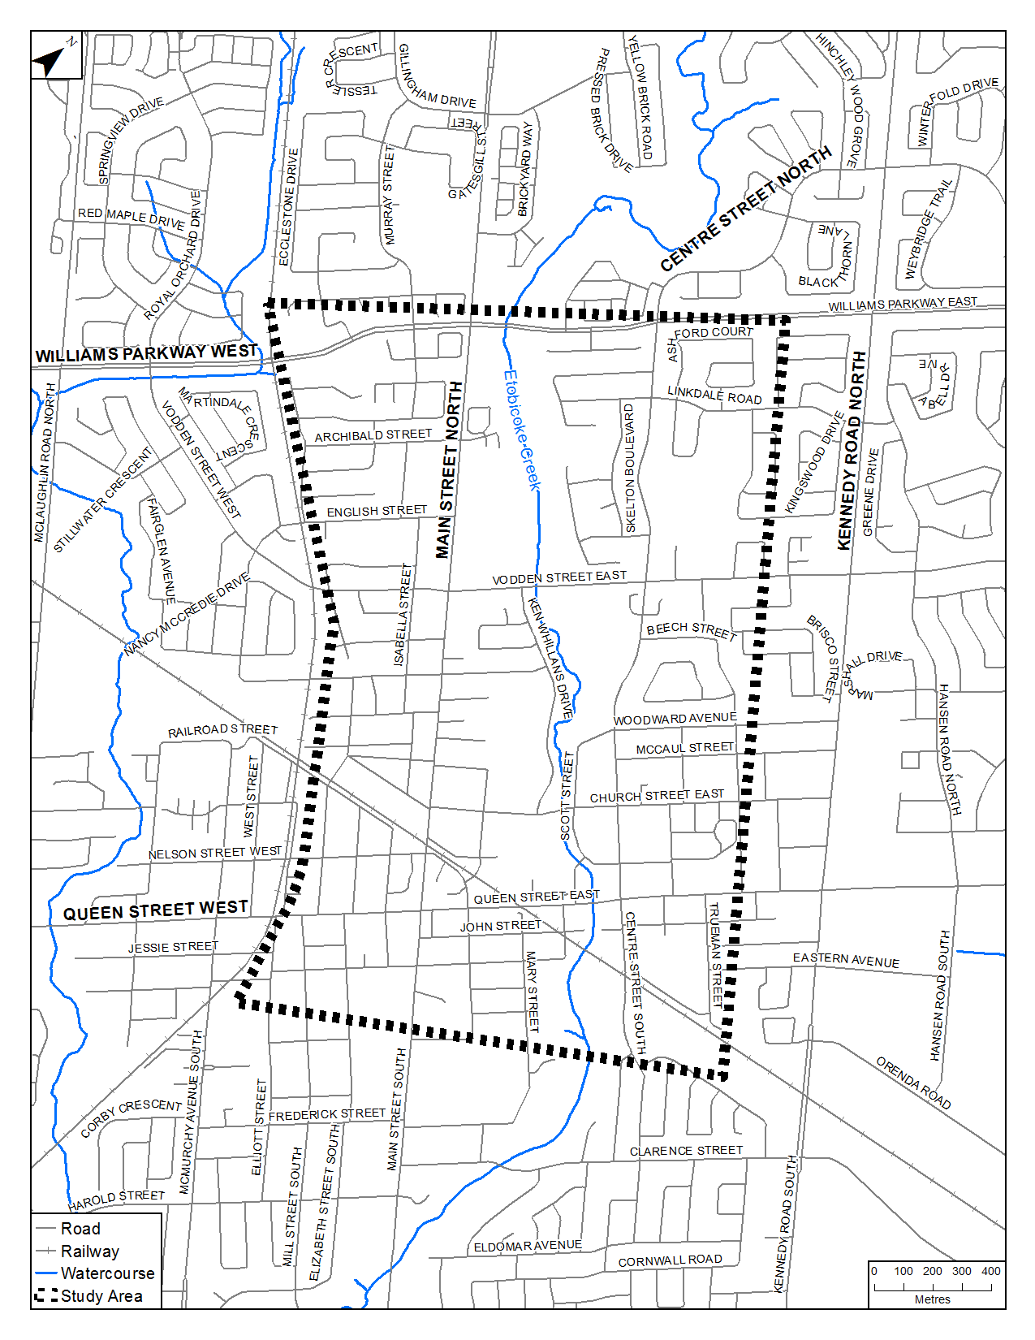
The Study
The Region of Peel (Region) is completing an Environmental Assessment (EA) study to select a preferred watermain route alignment in the City of Brampton. The study area for this Class EA is shown on the map.

As a result of the envisioned growth in the downtown area, the Region’s Water and Wastewater Master Plan has confirmed the need for a new watermain in Brampton. This new watermain will provide additional water supply to the growth area and will connect a new transmission watermain to be constructed along Williams Parkway with the existing watermain along Wellington Street and John Street.

The study will evaluate alternative solutions with the goal of providing additional water supply to the downtown area. The study will document the existing baseline conditions, evaluate the alternatives, and select the preferred solution to minimize impacts on the community and provide long-term flexibility to manage water demand and pressure in the system.
Your Input is Important
Due to current COVID-19 guidelines, Online Public Engagement has been arranged to provide members of the public an overview of the Class EA process and background information and an opportunity to provide input on alternative solutions.

Display boards will be made available to the public on peelregion.ca/public-works/environmental-assessments/#current and search under Brampton, beginning November 11, 2021. Paper copies of the display boards will be made available upon request. Please submit any questions or comments to the Project Manager listed below by December 2, 2021.

The results of the Study will then be published in a Project File and placed on public record for review.

Comments
If you have comments, require further information, or would like to be added to the project mailing list, please contact:

Jimmy Cheema
Project Manager, Capital Works
Water Linear Engineering & Reliability
Tel.: (905) 791-7800 x. 5403
Jimmy.Cheema@peelregion.ca
This notice was first issued on November 11, 2021.

The Region of Peel is committed to ensure that all Regional services, programs and facilities are inclusive and accessible for persons with disabilities. Please contact the Project Manager if you need any disability accommodations to provide comments or feedback for this study.

