NOTICE OF STUDY COMPLETION
West Trunk Sanitary Sewer Diversion

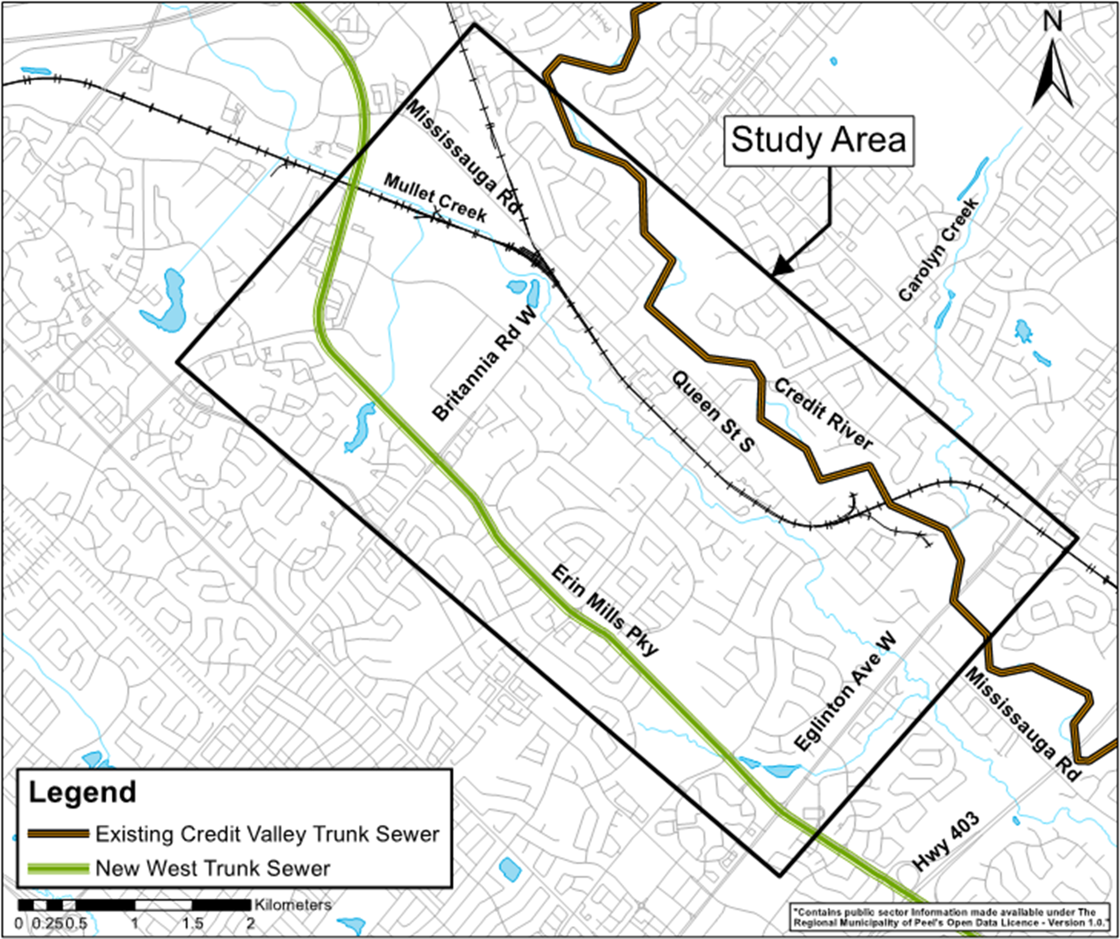
The Study
The Region of Peel has completed a Schedule ‘B’ Class Environmental Assessment (Class EA) for the West Trunk Sanitary Sewer Diversion Project. The approximate limits of the study area extend from Erin Mills Parkway to the Credit River, and from Eglinton Ave. West to the intersection of Erin Mills Parkway and Mississauga Rd., as shown in the map.

Preferred Solution
The purpose of the study was to identify a preferred solution to provide flow diversion from the existing Credit Valley trunk sewer to the newly constructed West Trunk Sewer at Erin Mills Parkway which would allow for future rehabilitation of the existing sewer. As part of the Class EA, a series of technical studies were completed to evaluate alternative solutions and identify mitigation measures to reduce impacts on the surrounding environment. The study is now complete, and the preferred solution includes:

- Single-leg diversion along Britannia Rd. West (east of Queen St. North), Mississauga Rd./Queen St. North/Queen St. South; along Erin Centre Boulevard; to Erin Mills Parkway;
- Construction via trenchless methods, anticipated to be at significant depths below the ground surface; and
- Construction of six shaft sites and staging locations, with minimal impacts on the socio-economic, natural, and cultural environments and transportation.

How To Get Involved:
A Project File Report (PFR) has been prepared and documents the planning and decision-making process, as well as consultation efforts. The PFR has now been filed with the Ministry of the Environment, Conservation and Parks (MECP) and is available to agencies, the public, stakeholders and Indigenous communities for a 45-calendar day review period. The PFR can be reviewed online at West trunk sanitary sewer diversion - Region of Peel (peelregion.ca). We invite you to review the PFR and provide written comments between May 5 and June 20, 2022, to the Project Manager:

Ajay Puri, M.E. (Env.), P.Eng.
Project Manager, Engineering
Wastewater Collection & Conveyance
Public Works, Region of Peel
Tel.: (905) 791-7800 x 5073
ajay.puri@peelregion.ca

A request may be made to the MECP for an order requiring a higher level of study (i.e., requiring an individual/comprehensive EA approval before being able to proceed), or that conditions be imposed (e.g., require further studies), only on the grounds that the requested order may prevent, mitigate, or remedy adverse impacts on constitutionally protected Indigenous and treaty rights. Requests on other grounds will not be considered. The request should include the author’s contact information and full name.

Requests should specify what kind of order is being requested (request for conditions or a request for an individual/comprehensive EA), how an order may prevent, mitigate, or remedy potential adverse impacts on Indigenous and treaty rights, and any information in support of the statements in the request. This will ensure that the MECP is able to efficiently begin reviewing the request. Requests should be submitted in writing or by email to:

Minister of the Environment, Conservation & Parks  Ministry of the Environment, Conservation & Parks  777 Bay Street, 5th Floor  Toronto, ON M7A 2J3  Minister.mecp@ontario.ca | Director, Environmental Assessment Branch  Ministry of the Environment, Conservation & Parks  135 St. Clair Avenue West, 1st Floor  Toronto, ON M4V 1P5  EABdirector@ontario.ca

Requests should also be copied to the Region of Peel’s Project Manager Ajay Puri.

Please visit the Ministry’s website for more information on requests for orders under Section 16 of the Environmental Assessment Act at: https://www.ontario.ca/page/class-environmental-assessments-section-16-order

This notice was first issued on April 28, 2022

