NOTICE OF VIRTUAL PUBLIC INFORMATION EVENT
West Trunk Sanitary Sewer Diversion

The Study
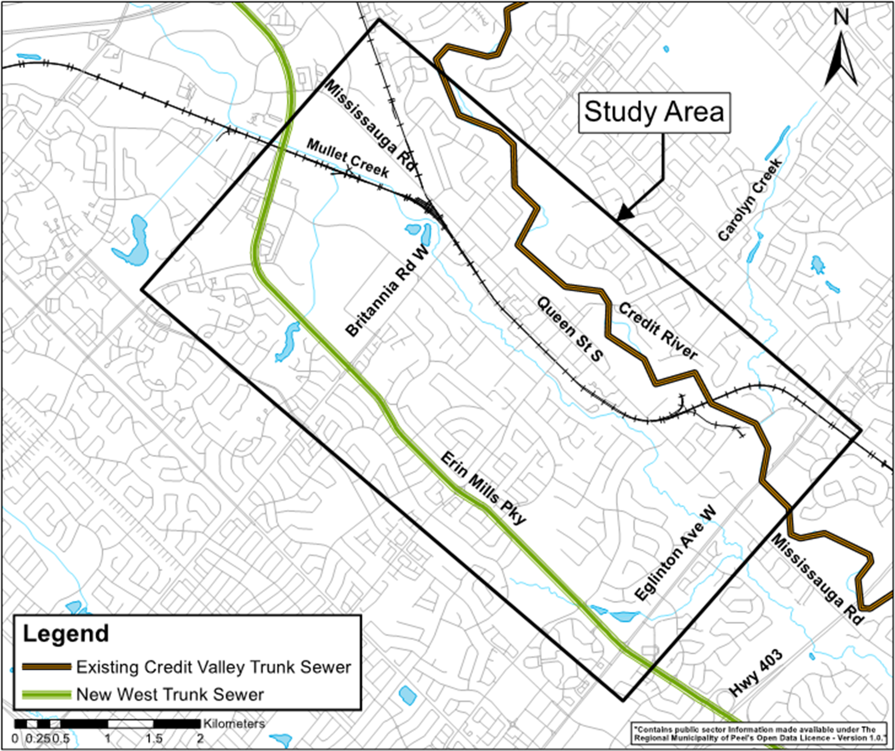
The Region of Peel is currently undertaking a Schedule ‘B’ Class Environmental Assessment (Class EA) for the West Trunk Sanitary Sewer Diversion. The approximate limits of the study area extend from Erin Mills Parkway to the Credit River, and from Eglinton Ave. West up to the intersection of Erin Mills Parkway and Mississauga Rd., as shown in the map.

The purpose of the study is to identify a preferred solution to provide flow diversion from the existing Credit Valley trunk sewer to the newly constructed West Trunk Sewer at Erin Mills Parkway to allow for future rehabilitation of the existing sewer.

The Study Process Includes:
- Public and Stakeholder meetings
- An evaluation of alternative solutions
- The identification of a preferred solution
- Mitigation measures to reduce impacts on the surrounding community.

Virtual Public Information Centre
As part of this Project, one Public Information Centre (PIC) will be held to receive input from the public, interested stakeholders and Indigenous groups. Due to COVID-19 and current provincial guidance on public gatherings, the PIC material will be posted online at peelregion.ca/public-works/environmental-assessments/#current and search under Mississauga, West Trunk Sanitary Sewer Diversion. The material will include a summary of the background information and the evaluation and identification of the preliminary preferred solution. The PIC material will be made available from Sept. 20, 2021 until Oct. 19, 2021. Comments will be received until Oct. 19, 2021. A summary of questions and answers will be posted online following the PIC.

A Project File Report (PFR) will be filed with the Ministry of the Environment, Conservation and Parks at the end of the study and made available to agencies, the public and Indigenous groups for a 30-calendar day public review period. A separate Notice of Study Completion will be issued to announce the locations where the PFR can be viewed.

Comments
If you would like to provide comments or have questions, or if you would like to be added to the Project Contact List, please contact the Project Manager listed below.
Ajay Puri, M.E. (Env.), P.Eng.  Project Manager, Capital Works  Wastewater Division  Tel.: (905) 791-7800 x 5073  ajay.puri@peelregion.ca | This notice was first issued on September 16, 2021.

