Update on construction in your area

The Region of Peel is replacing aging watermain on Indian Grove as part of our maintenance program. The current watermain was installed in the 1950s and is at the end of its lifespan.
A larger watermain that provides water to the Lorne Park area will also be installed along with the smaller (local) watermain on Indian Grove. The local watermain is on one side of the street with the larger watermain to follow on the opposite side of the street.

Completed work

- The contractor paved South Sheridan Way and a section at the north end of Indian Grove. The contractor will need to return in spring 2022 to pave the top coat of asphalt as this work requires warmer temperatures.
- The contractor installed a closure piece on Indian Road to connect a section of the new watermain to the existing watermain.
- Sections of temporary asphalt curb have been installed in advance of the winter. Most driveway aprons have also been temporarily restored with asphalt until final restoration is completed in spring 2022. If we damaged your driveway and cannot fully repair it before winter, we have put down a thin layer of asphalt so we don’t leave your driveway as gravel. This will be removed in the spring when the weather allows for proper restoration.
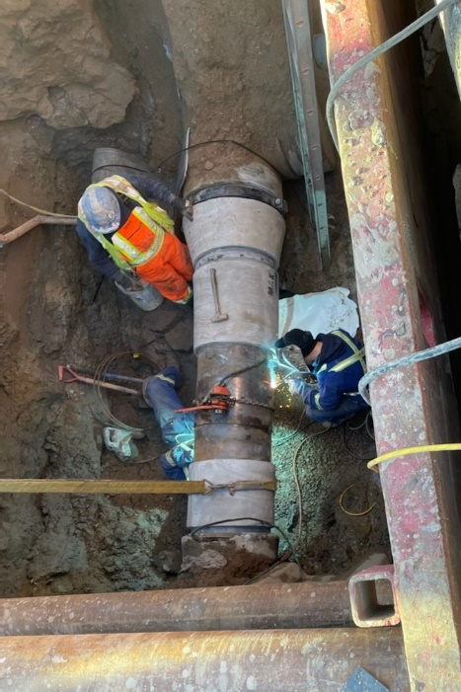
Welding closure piece in place to connect new watermain to existing watermain
Resident questions/concerns

- Residents have inquired about how the site will be left until the contractor returns in the new year. The road will be clear of material and equipment and two way traffic will be restored. The temporary sidewalk on the east side of Indian Grove will be restored and temporary asphalt curb will be placed on the west side of the street.
- Residents had expressed concern that leaf piles were left during the City’s leaf collection. The City has since returned to site and removed the remaining piles of leaves.
- Construction vehicles and equipment can sometimes block the road. On busier roads like South Sheridan Way and Indian Road, the contractor should be using flaggers to direct traffic around the work where two lanes of traffic cannot be maintained. Yield to Oncoming Traffic signs may be used on quieter roads with clear lines of site.

Coming up in the next two weeks

The Contractor will:
- Continue temporary restorations, including temporary paving of driveway aprons, reinstating temporary sidewalk, and constructing temporary asphalt curb before the winter. Final restoration of driveways, curb, sidewalk, and road paving will be completed in spring 2022.
- The Contractor will be shutting down for the winter the week of December 20, with some watermain work at the beginning of the week and minor site clean up following.
- The temporary sidewalk will not be maintained during the winter. Residents should use the existing sidewalk on the south/east side of the road.

Anticipated completion

- We are on schedule to complete most of the work (including most digging) by the end of 2021. Due to unforeseen circumstances, we will need to do some digging in the spring. Two final connection pieces will need to be installed in spring 2022. This will only be for a couple of weeks and residents will be advised in advance. Final restoration work (i.e. paving, curb and sidewalk, driveways, sod and landscaping) will also be completed in spring 2022.

Reducing the impact of construction

- A road closure is in place on Indian Grove during construction. Residents will be allowed to access their properties, but no through traffic will be allowed.
- For everyone’s safety, please do not drive through the active construction area. Residents should access their property from the south end of Indian Grove if their property is south of the active construction area, and from the north end if their property is north of construction.
- We may need to block your driveway for a short time. We will contact you to arrange for the best time and for alternate access, if needed. Pedestrian access will always be maintained.
- We may need to temporarily shut off your water when connecting to the new watermain. It is our goal to let you know 48 hours (2 days) in advance if we need to do this. Occasionally, we may have to reduce this notice to 24 hours. We will do our best to notify you.
- If we must shut off your water because of an emergency, we will do everything we can to fix the problem as quickly as possible.
- We will let you know if there are any significant project changes.

In-ground sprinkler systems

- We recommend that you remove your sprinkler lines within 3 metres of the curb to avoid damage.
- Please email us if you would like to discuss your underground irrigation or sprinkler system outside your property line.

Did you know?

- In Southern Ontario, the frost line is approximately 1.2m below the ground surface. This means that anything shallower than 1.2m is at risk of freezing during periods of low temperatures. Municipalities set minimum depths for infrastructure such as watermains and water services to ensure that the water does not freeze. Where minimum depths cannot be met, insulation must be used to protect the watermain.

Questions or concerns?
- Visit the project webpage for ongoing updates
- Call 905-791-7800 extension 4409
- Email construction@peelregion.ca

View the web version
Accessible formats and communication supports are
available upon request.

Region of Peel | 10 Peel Centre Drive, Brampton, Ontario L6T 4B9 Canada

Unsubscribe
Update Profile | Our Privacy Policy | Customer Contact Data Notice
Sent by construction@peelregion.ca

