NOTICE OF STUDY COMPLETION

NEW SUPPLEMENTARY WATER SUPPLY SOURCE FOR THE PALGRAVE-CALEDON EAST DRINKING WATER SYSTEM
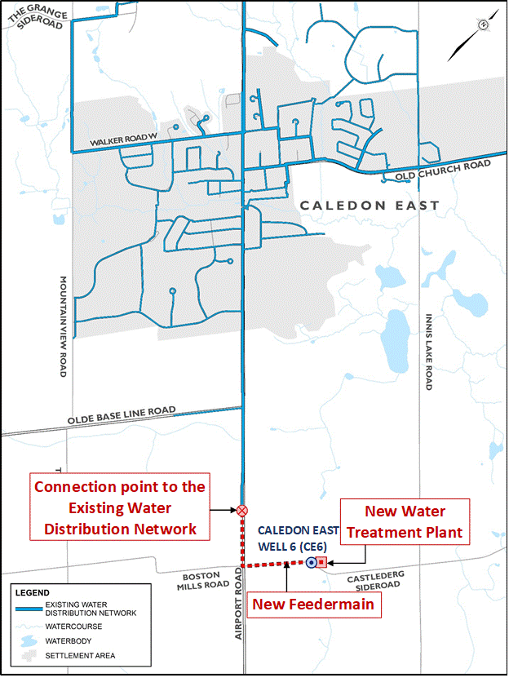
The Class EA Study
Peel Region has completed a Municipal Class Environmental Assessment (Class EA) Study to enhance the water supply capacity of the existing Palgrave-Caledon East Drinking Water System to meet the long-term water needs of the serviced area.
The study has been conducted in accordance with the requirements of a Schedule ‘C’ project under the Municipal Class Environmental (Class EA) Assessment document (February 2024) which is approved under the Ontario Environmental Assessment Act. The Class EA study included a comprehensive assessment of water servicing alternatives to identify the necessary infrastructure improvements for increasing the supply capacity of the existing Palgrave-Caledon East Drinking Water System.
The study has identified the preferred recommended solution as the connection of a new municipal production well to the existing Caledon East distribution system. The new municipal production well was constructed in 2020, on a parcel of land located to the north Castlederg Side Road, east of Airport Road. The preferred recommended solution comprises the following major infrastructure, illustrated in the figure:
- A new water treatment plant adjacent to the new municipal production well, providing treatment for disinfection; and,
- A 1-km long feedermain along Castlederg Side Road and Airport Road to provide for the connection between the new water treatment plant site and the existing Caledon East water distribution system on Airport Road.

Your Opinion Matters
An Environmental Study Report (ESR) has been prepared to document the planning and decision-making process, as well as consultation efforts, followed in the Class EA Study. By this notice, the ESR is being placed on the public record for a 30-calendar day review period from June 17, 2024, to July 17, 2024. The ESR will be available for public review on the Region’s website at peelregion.ca/public-works/environmental-assessments/caledon/revised-project-name.asp
Peel Region is committed to ensuring that all regional services, programs, and facilities are inclusive and accessible for persons. Please contact the Project Manager if you need any accommodations to provide comments or feedback for this study. All requests must be received within the review period. Interested persons may provide written comments to our project team on or before July 17, 2024. All comments and concerns should be sent directly to Luis Lasso at Peel Region by mail or e-mail.
Luis Lasso, P.Geo QPRA
Program Manager – Water Resources Planning
Water & Wastewater Infrastructure Planning
Region of Peel
10 Peel Centre Dr., 4th Fl., Suite A | Brampton, ON L6T 4B9
905-791-7800 ext. 4646
luis.lasso@peelregion.ca
In addition, a request may be made to the Ministry of the Environment, Conservation and Parks for an order requiring a higher level of study (i.e., requiring an individual/ comprehensive EA approval before being able to proceed), or that conditions be imposed (e.g., require further studies), only on the grounds that the requested order may prevent, mitigate or remedy adverse impacts on constitutionally protected Aboriginal and treaty rights. Requests on other grounds will not be considered. Requests should include the requester contact information and full name.
Requests should specify what kind of order is being requested (request for additional conditions or a request for an individual/comprehensive environmental assessment), how an order may prevent, mitigate or remedy those potential adverse impacts, and any information in support of the statements in the request. This will ensure that the Ministry is able to efficiently begin reviewing the request. The Section 16 Order request should be sent to the Minister of Environment, Conservation and Parks and the Director of Environmental Assessment Branch. You can submit your request by mail, email or hand delivered to:
Honourable Andrea Khanjin, Minister
Ministry of Environment, Conservation and Parks
777 Bay Street, 5th Floor
Toronto ON M7A 2J3
minister.mecp@ontario.ca
and
Director, Environmental Assessment Branch
Ministry of Environment, Conservation and Parks
135 St. Clair Ave. W, 1st Floor
Toronto ON, M4V 1P5
EABDirector@ontario.ca

Requests should also be copied to the Peel Region’s Project Manager, Luis Lasso by mail or by e-mail. Please visit the ministry’s website for more information on requests for orders under section 16 of the Environmental Assessment Act at: ontario.ca/page/class-environmental-assessments-part-ii-order.

The Notice of Completion was first issued on June 20, 2024.

This notice was first issued on XXX

