Water treatment plant virtual tour
Teacher guide

Table of contents
Introduction 1
Why a virtual tour? 1
Program overview 1
How to use the tour 2
Navigation 2
Option 1: Student self-exploration (in-class or virtual learning) 3
Option 2: Teacher-led exploration (on smartboard/screen) 3
Introduction 3
1 - The Arthur P. Kennedy Water Treatment Plant 4
2 – Control Room 5
3 – Lake Ontario 7
4– Mechanical Screens 8
5 – Ozone Generation Room 10
6 – The Bridge 11
7 – BACC (Biologically Active Carbon Contactor) 12
8 – UV 13
9 – Membrane Gallery 15
10 – Wet Lab 16
11 – Distribution 17
12. Closing 17
Extension Activities 18
Virtual tour handout 18
Virtual tour handout 19
Virtual tour handout answer key 22
Curriculum Connections 25

Introduction
This virtual tour offers a behind-the-scenes look at the drinking water treatment process and is curriculum connected for grades 8-12. The virtual tour can be used as a stand-alone activity or can kick-start further exploration and learning.

Why a virtual tour?
The Arthur P. Kennedy Water Treatment Plant Virtual Tour was created to provide teachers and students with unlimited virtual access to the Arthur P Kennedy Water Treatment Plant to learn more about the facility and how water treatment works in Peel. This virtual tour gives teachers and students the opportunity to access the tour route on their own time and at no cost.

Program overview

Key Themes:
Water treatment, drinking water awareness, human water cycle, careers, water quality

Learning goals:
At the end of the virtual tour program, students will be able to:
- Identify the main stages of water treatment
- Explain the importance of clean drinking water

Technology requirements:
To access the tour, students will need access to a computer lab, tablets or other internet-enabled devices or have shared access to a smart board/projector screen. The tour can be accessed on a smart phone but works best on a larger screen.

The virtual tour can be accessed in different internet browsers but is optimized for Google Chrome.

How to use the tour
There are two delivery methods for this tour:
- Student self-exploration: Students can access and explore the tour on their own devices while using the provided handout as a guide
- Teacher-led: If there is access to a class smart board/projector screen, the teacher can facilitate the virtual tour, and use this guide and accompanying discussion questions to facilitate class-wide discussions.

We recommend reviewing the optional pre-tour activities with the class before navigating through the virtual tour. These optional activities include short videos and discussion questions that will help introduce the topic of water conservation and water treatment. They can be found on our tour website by visiting https://peelregion.ca/environmental-education/water-treatment-virtual-tour.asp

Navigation
The virtual tour is easy to navigate. There are 12 tour stops, and each stop can be navigated to using the left-hand panel of images. You can also navigate between stops by selecting the “past location” and “next location” buttons at the bottom of the screen. As you move between stops, a text box will pop-up summarizing the importance of that stage in the tour.

Each tour stop has clickable buttons to provide more information and photos.

Button | Purpose
 | Information about each stage
 | Did You Know? facts
 | Video clips

You can use the computer mouse or trackpad to click and drag around each stop for a 360-degree panoramic view. You can also zoom in on areas of the tour for a closer look – simply scroll forward and backwards using your mouse or pinch your laptop trackpad. If you’re working from a touch screen, you can move by touching the arrows icons, dragging across the screen to move, and pinching out to zoom in.

Option 1: Student self-exploration
(in-class or virtual learning)
In this option, students navigate through the water treatment tour at their own pace and can use the accompanying handout to guide their learning. Each stage has a 360-degree view and students are encouraged to explore as much as they can.

If students are unsure which water treatment stage they are in, they can click the stages on the left-hand side of the screen or click the next or previous buttons on the bottom of the screen.

Option 2: Teacher-led exploration
(on smartboard/screen)

In this option, the teacher leads the class through the virtual tour as a group using a smart board, computer and projector, or online learning platform.

Below you will find a step-by-step guide for exploring the virtual tour as a group, including speaking notes, a summary of interactive point within the tour and suggested discussion questions.

Introduction
The tour begins at a landing page that explains how to navigate through the tour; you can use your mouse, keyboard, or click on the arrows on the screen to move forward. The landing page also outlines the three different symbols you can look for fun facts, pictures, videos and more information on the Region of Peel’s drinking water.

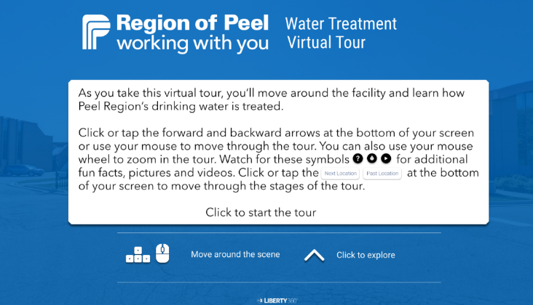

You can click anywhere on this landing page and it will take you to the tour.

1 - The Arthur P. Kennedy Water Treatment Plant
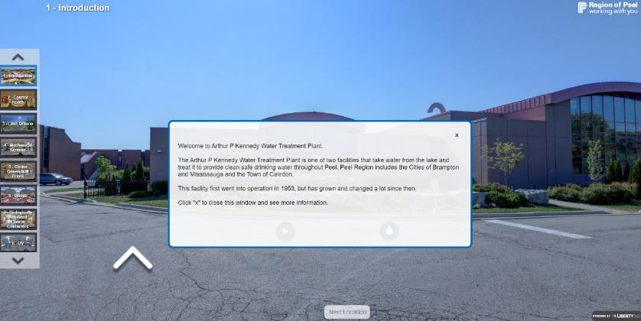

Discussion questions
These questions could be asked to the class before you begin. If you have completed the pre-tour activities these questions may not be needed, or you may wish to modify them.

Have you learned about water treatment before?

Does anyone know where our drinking water comes from?
Answer: Lake Ontario or, if you live in some areas of rural Caledon, it may come from a well.

Why do we need to treat the water before we drink it?
Answer: To remove any bacteria, viruses or other pollutants and ensure the water is safe to drink.

What kinds of processes might be involved in ensuring water is clean and safe to drink?
Answer: Filtration, disinfection, etc.

Starting the tour:
You will see the outside of the Water Treatment Plant. There is an introductory textbox with background information on the facility.
When you close this box, you will see a and a button – select these for more information and for a brief video about water treatment in peel. Note: this video is the same video from the optional pre-tour activity, feel free to skip this if you have already viewed it with the class.

You can use the mouse to click and drag to view the area outside the water treatment plant, and you can select the arrow on the left to move towards the front door. To move on to the next stage, click the second arrow to enter the building, or click the second stage on the left-hand navigation bar “2. Control Room” or select “Next Location” at the bottom of the screen.

2 – Control Room
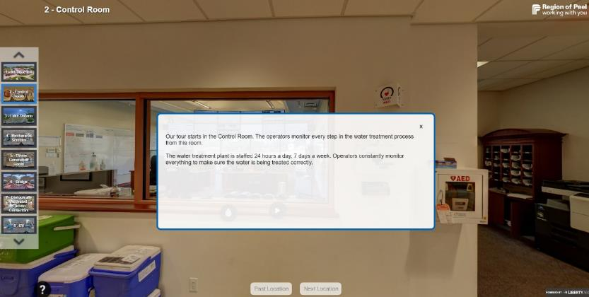

You will be brought inside the facility and have a view of the control room inside treatment plant. The introductory text explains the purpose of the control room.

Button actions
Button | Purpose
 | Plays a short video that zooms in on the control room.

Discussion questions
Why do you think it’s important that people are always monitoring the treatment process?
Answer: To make sure the process is running properly and that the water is being treated correctly.

What education do you think is needed for a career in water treatment?
Answer: There are many water treatment related careers. You can dive into a career right out of high school by first passing the Operator in Training exam and taking an entry-level drinking water operator course prior to applying for a job! You can also look at diplomas, certificates or degrees in environmental science or engineering. For more career information, check out the Ontario Clean Water Agency’s website! http://www.ocwa.com/

What other types of jobs do you think are available in water treatment and distribution?
Answers: Engineer, lab technician, welder, operators, water monitoring, construction, educators etc.

Button actions
Button | Purpose
 | Provides more information on careers in water treatment.
 | Explains the purpose of the coolers along the wall.

Before moving to the next stage, we recommend the following discussion question:

Next, we will be moving to the Lake. Water is taken from far out in the lake to be treated. Why do you think this is?
Answer: The water is cleaner further away because there are fewer human activities away from the shore.

3 – Lake Ontario
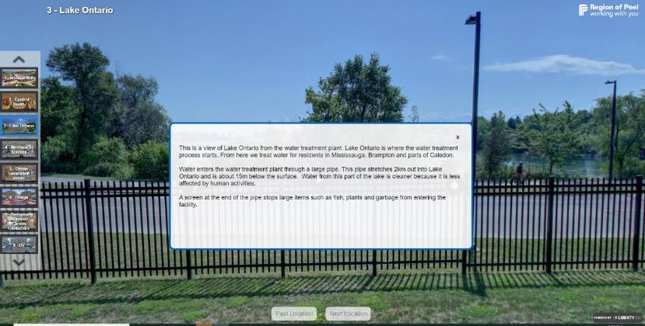

The intro textbox explains the importance of Lake Ontario as the Region of Peel’s source for drinking water.
You can then exit the text box and select the on the right-hand side of the screen for more images and information about Lake Ontario.

Discussion questions
What activities might impact the quality of water in the lake?

Answer: Various types of human activities can lead to pollution. Trash, sewage, fertilizer; soil and other debris from rainstorms that gets pushed into the lake; oil spills and debris from boats etc.

What are some ways we can protect our waterways? Why is protecting our water important?

Answer: We can protect our waterways by reducing pollution and using water efficiently, so it is available for future generations. We need out waterways for drinking water, habitat for fish and other aquatic wildlife, and it’s an important recreational space for many people.

How many swimming pools worth of water do you think the treatment plant can treat in one day?

Answer: 228 Olympic sized swimming pools

Button actions
Button | Purpose
 | Opens a quick video explaining the importance of the intake pipe.
 | If you move to the left, you can press this button for facts about water treatment.

4– Mechanical Screens
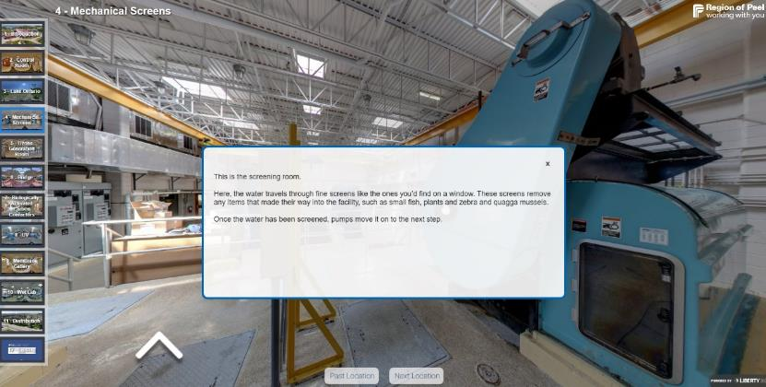

The first button on the left-hand side shares some information about zebra and quagga mussels and the problems the pose for water treatment. This big blue machine holds the fine screens that help remove debris and mussels from the water, so they don’t clog up the pipes as the water moves through the treatment plant.

Discussion questions
What are invasive species?
Answer: any living organisms that is not originally found in a habitat that causes environmental harm.

Why are zebra mussels such a problem in Lake Ontario?

Answer: They cause damage in a number of ways – as filter feeders, they filter and eat lots of plankton leaving much less available for other species in the food chain. The removal of plankton also results in clearer water, which means more sunlight can penetrate deeper in the water, leading to more vegetation. The zebra mussels can also impact spawning areas for fish!

If you navigate 180 degrees, you’ll find a white directional arrow next to a second mechanical screen. Click this arrow to move further into the mechanical screening room and click the next directional arrow that appears to continue moving forward. This will bring you to two additional engagement points:

On the wall: to get information on the panels on the wall

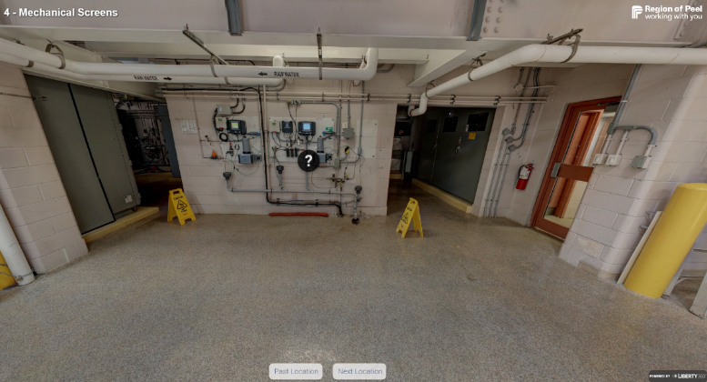

On the large blue pumps: to find out more about these pumps

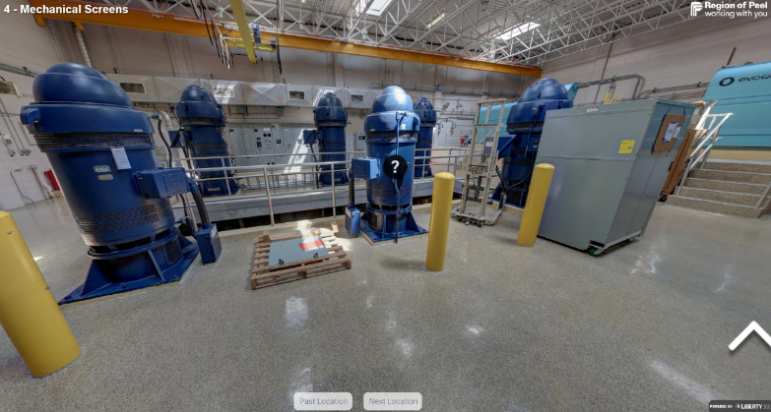

5 – Ozone Generation Room
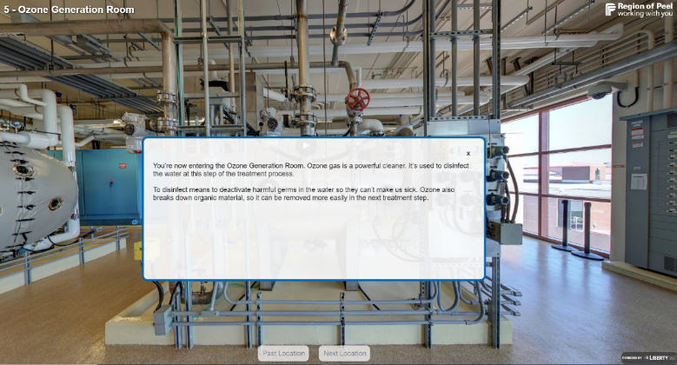

Discussion question
What is ozone?

Answer: Ozone is a gas O₃ – it is found naturally in the Earth’s upper atmosphere – it is naturally formed when solar UV rays from the sun react with oxygen (O₂). Here, ozone is made in the water treatment plant by using electricity to convert oxygen into ozone!

Button actions
Button | Purpose
 | interesting facts about the ozone generator. Ozone gas is unstable, so it is made on-site in this generator and then stored in large tanks.
 | an image of the ozone contactors where the ozone is added to the water.
 | a quick video explaining the entire process of adding ozone.

Follow the directional arrow to the right to get a better view of the ozone generation room.

Follow the arrows to the left, to see a final button on top of a yellow box next to an ozone generator:

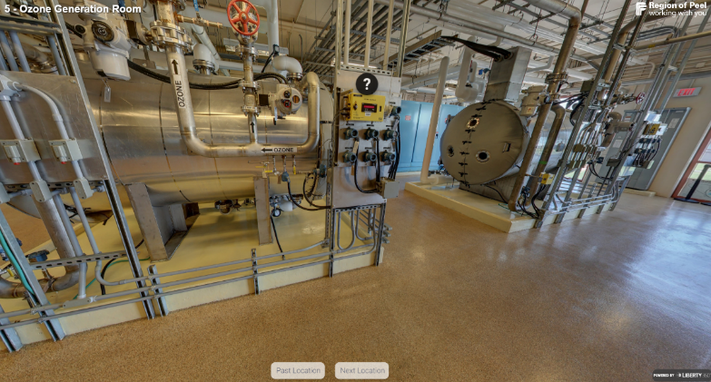

6 – The Bridge

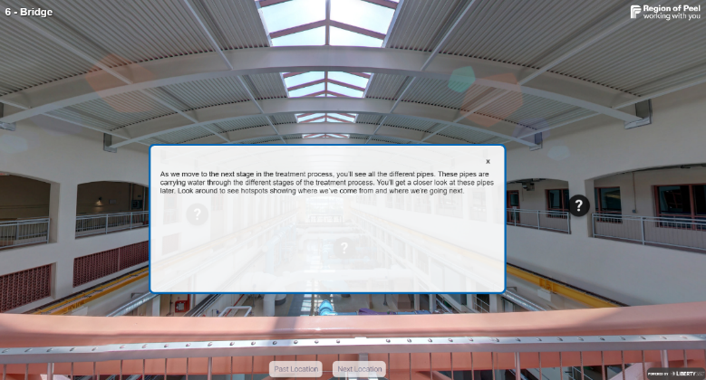

This step in the tour gives you an aerial view of the various pipes involved in the water treatment process.

There are four buttons here that will help orient students with where the various water treatment stages are located.

7 – BACC (Biologically Active Carbon Contactor)
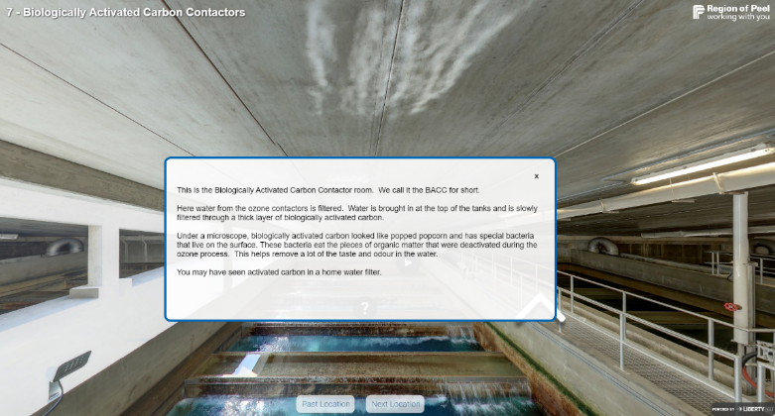

This is where the water from the ozone contactors is filtered.

Button | Purpose
 | Additional details on how this process works.
 | Opens a short, animated video of the biologically activated carbon contactors.

Discussion question
Does this carbon contactor remind you of something you may have at home?

Answer: this is very similar to how your Britta water filter works; the filter also has carbon in it. Unlike your home Britta filter, where you throw away the filter when it is time to change it – the activated carbon at this facility gets cleaned through a process called backwashing. In backwashing, all the organic matter is pushed to the top by water pressure and air – the dirt flows away, leaving clean carbon behind!

Follow the directional arrows to explore the other contactors in this room.

Discussion question
Why do you think there’s an empty tank?

Answer: this ensures that if water demand increases, the Region of Peel has the space to accommodate growth and can treat more water.

8 – UV
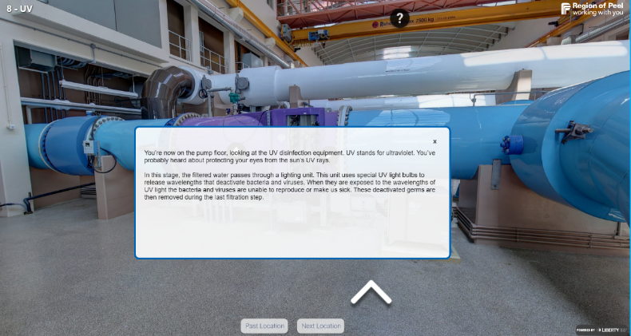

We are now on the same floor as the pipes that we saw earlier from the bridge. This is where the UV disinfection equipment is located.

Button actions
Button | Purpose
 | Image that explains UV light in more detail
 | Explains the role of the blue pipe
 | Short video demonstrating how viruses are deactivated inside the reactor.

Navigate counterclockwise to see a button that explains the function of the brown pipes in the facility:

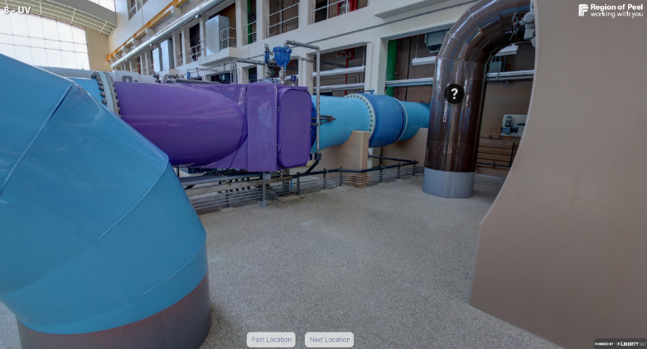

You’ll need to turn around after examining the brown pipe to find the navigation arrow.

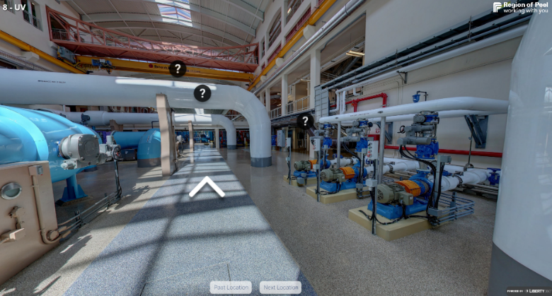

As you follow the arrows forward, there are three buttons describing features of the pipe room in more detail:

Continue through the room by following the directional areas until you come to the last set of buttons at this stop. Here you can learn more about the green pipes, blue pipes, red pipes and the yellow floor markers:

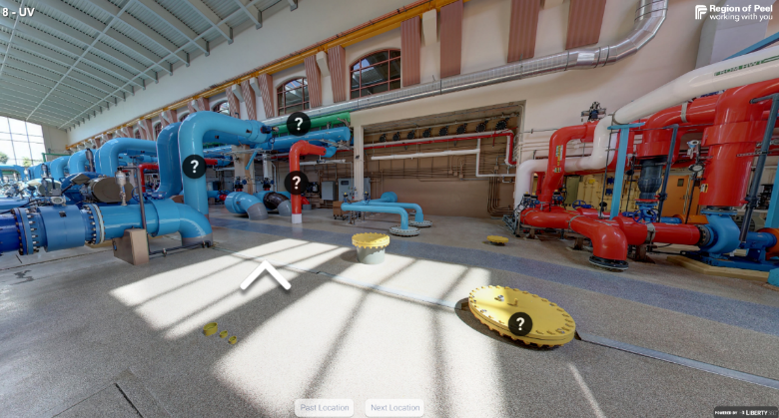

9 – Membrane Gallery
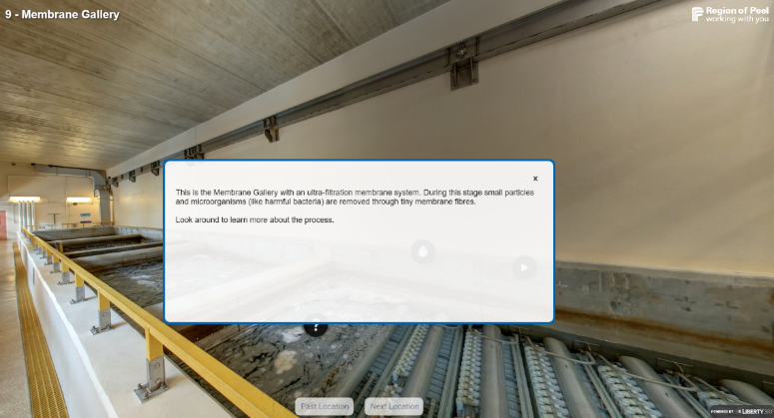

This is the final filtration stage for Peel’s drinking water.

Button actions
Button | Purpose
 | Explains the importance of keeping the membranes clean.
 | Shows a closeup of the membrane tank cassettes and the modules
 | A short video demonstrating how this filtration process works.

Navigate to the right to see the button on the blue crane to see a close up of an operator using the crane to check the cassettes.

10 – Wet Lab
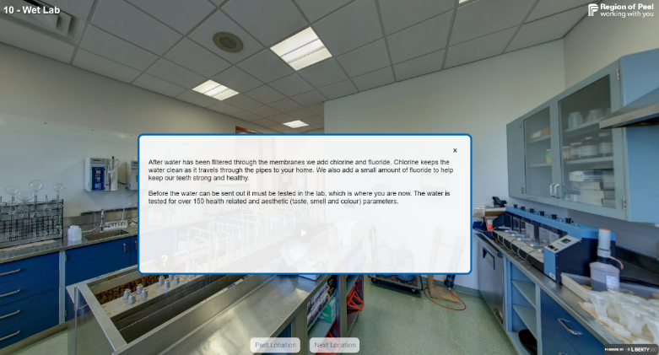

Button actions
Button | Purpose
 | Learn about the various taps seen in the wet lab.
 | There are two of these buttons that show some of the tests conducted to ensure the water is safe to drink!
 | A short video demonstrating how this filtration process works.

Discussion questions
What kind of equipment can you identify in here?

Answer: beakers, chemicals, water taps, scales, gloves, safety jacket, emergency eye wash station, storage closet etc.

Why is it important that we test our water from various stages of the treatment process and multiple times a day?

Answer: to make sure it is safe to drink and that each stage of the treatment process is functioning properly

11 – Distribution
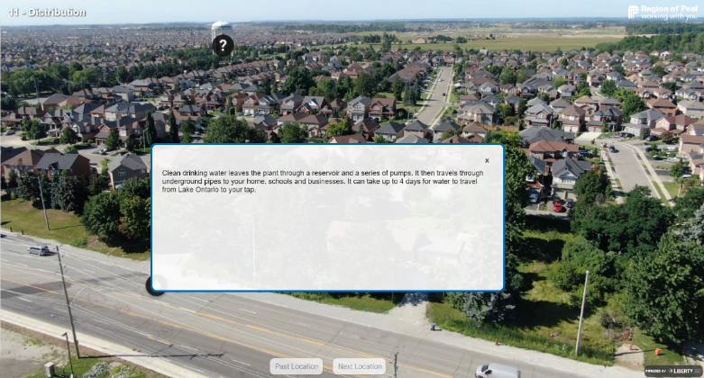

Button actions
Button | Purpose
 | provides information on distribution button and how water quality is maintained through the distribution system.
 | shows the different pressure zones in the Region of Peel. Pressure zones are shown in different colours and change as you get further from the lake.

12. Closing

Discussion questions to ask students at the end of the tour
Why is it important to not waste water, based on what you learned during the tour?

Answer: The water treatment process is long and intensive; it requires a lot of energy. If we conserve water, we can reduce the energy needed to clean and treat it.

Answer: Be cautious of leaving the tap running, check for leaks, water the lawn less etc.

What are some new things you learned about water treatment? Did anything surprise you?

How can we reduce water usage at home and at school?

Answer: how much water the Region of Peel treats, how many stages are involved, how often water is tested etc.

Extension Activities
For additional activities for connecting the virtual tour concepts with curriculum, please visit our library of extension studies:

https://www.peelregion.ca/environmental-education/water-wastewater.asp#activities

Virtual tour handout
The handout that accompanies this tour is customizable – feel free to amend or update as needed. The handout can be printed and filled out by hand or completed as a word document. It is also available as a stand-alone word document online:
https://peelregion.ca/environmental-education/water-treatment-virtual-tour.asp

Virtual tour handout
Fill in the table below as you complete the water treatment plant tour.
 | Describe the importance of this stage to water treatment | What did you find interesting about this tour stop?
1. Introduction
2. Control Room
3. Lake Ontario
4. Mechanical Screens
5. Ozone Generation Room
6. Bridge
7. Biologically Activated Carbon Contactors (BACC)
8. UV
9. Membrane Gallery
10. Wet Lab
11. Distribution

Additional notes:

Virtual tour handout answer key
Sample answers have been added. Note that there is more than one correct answer.
 | Describe the importance of this stage to water treatment | What did you find interesting about this tour stop?
1. Introduction |  | The water treatment plant went into operation in 1953.  There are two treatment plants that take water from the lake.
2. Control Room | The control room is where operators monitor the treatment process and ensure that the water is clean and safe. | The facility is staffed 24/7.  There are lots of career opportunities in water treatment.
3. Lake Ontario | Lake Ontario is where our drinking water comes from. It is brought into the plant through an intake pipe. | The intake pipe is 2km long.  There is a screen at the end of the pipe to keep fish, plants and large pieces of garbage out of the treatment plant.
4. Mechanical Screens | The water travels through mechanical screens to remove any fish, plants or small pieces of garbage that made their way through the intake pipe. | Zebra and quagga mussels can block the pipes in the treatment plant so chlorine is added to remove them.
5. Ozone Generation Room | Ozone is used as a disinfectant to clean the water. It is added to the water in the ozone contactors. | Ozone is unstable so it is made onsite using Oxygen and electricity.  There are a lot of monitors and screens so that the operators can check on the treatment process.
6. Bridge |  | The building and pipes are bigger than I expected. The pipes are different colours.
7. Biologically Activated Carbon Contactors (BACC) | The water travels through a layer of biologically activated carbon which filters out the organic material that was disinfected during the previous step. This removes a lot of the taste and odour from the water. | Under a microscope, the carbon looks like popped popcorn.  The carbon used here is the same material as what is in my home water filter.

8. UV | UV stands for ultraviolet. The water passes through an ultraviolet reactor which uses UV lights to deactivate bacteria and viruses. | Each lightbulb lasts for 12,000 hours.  It was interesting to learn about the different coloured pipes and the crane.
9. Membrane Gallery | Membranes are tiny tubes like a pool noodle or straw that filter the water. There are tiny holes all along the outside that are so small that only water can get through. | Each module contains approximately 35,000 fibres.  The membrane fibres are cleaned regularly.
10. Wet Lab | The lab is where the water is tested. It is important to test the water to ensure that it is clean and safe to drink. | Water is tested from various stages of the treatment process. The taps bring the water directly to the lab to be tested.
11. Distribution | Once the water is clean, it leaves the plant through a reservoir and a series of pumps. It then travels through underground pipes to homes, schools and businesses. | Water can be stored in water towers or underground reservoirs.  The Region is divided into different pressure zones based on the distance from the plant and how hilly or flat the area is.

Additional notes:

Curriculum Connections
Additional connections can be made through extension activities:

Grade 8
Subject & Unit | Specific Expectations
Science & Tech: Understanding Structures & Mechanism: Water Systems | - Investigate how municipalities process water (e.g. obtain it, test it, treat it) and manage water (e.g. distribute it, measure consumption and dispose of wastewater)  - Evaluate personal water consumption and propose a plan of action to reduce water consumption to help address water sustainability issues  - Assess the impact on local and global water systems of a scientific discovery or technological innovation
Geography: Global Settlements: Patterns & Sustainability | - Describe various ways human settlement has affected the environment (e.g. water pollution from industry…)  - Describe some practices that individuals and communities have adopted to help make human settlements more sustainable (e.g. reducing water use)

Grade 9
Subject & Unit | Specific Expectations
Geography: Livable Communities | - Assess the impact of urban growth on natural systems (e.g. impact of urban sprawl (what impact might an increase in population density have on treatment processes and on nearby bodies of water?)  - Identify various ways in which communities dispose of their waste material (e.g. incineration, primary and secondary sewage treatment) and describe potential environmental impacts of these methods
Geography: Interactions in the Physical Environment | - Explain how human interactions in their local region can have an impact on natural processes
Technology: Technology, the Environment, and Society | - Describe how various technologies (e.g. water purification) affect the environment and identify important environmental considerations associated with different areas of technology

Grade 10
Subject & Unit | Specific Expectations
Technology – Technology, the Environment, and Society | - Identify ways in which green industry activities affect the environment (e.g. Contamination of water)
Technology – Health Care, the Environment, and Society | - Identify current environmental issues and describe their implications for human health and well-being (e.g. water quality and human health)
Careers | - Identify some recent and evolving technological, economic and social trends that have influenced the world of work and analyze the possible impacts of those trends on their own choices  - Use a research process to identify and compare a few postsecondary options that suit their aspirations, skills, interests, values and personal circumstances  - Identify the pathways towards their preferred destinations

Grade 11
Subject & Unit | Specific Expectations
Chemistry | - Analyze the properties of commonly used chemical substances and their effects on human health and the environment, and propose ways to lessen their impact  - Analyze chemical reactions used in a variety of applications, and assess their impact on society and the environment  - Analyze the origins and cumulative effects of pollutants that enter our water systems (e.g. landfill leachates, agricultural run-off, industrial effluents, chemical spills) and explain how these pollutants affect water quality  - Analyze economic, social, and environmental issues related to the distribution, purification or use of drinking water (e.g. the impact on the environment of bottled water)
Environmental Science | - Analyze initiatives (both governmental and non-governmental) that are intended to reduce the impact of environmental factors on human health  - Investigate environmental factors that can affect human health and analyse related data  - Plan and conduct an inquiry to compare water quality in natural and disturbed environments (e.g. compare pH, temperature, dissolved oxygen content, turbidity, etc., of tap water, water from a pond or stream and water from a drainage ditch)  - Identify the basic components of soil, water and air and describe some of the effects of human activity (e.g. chlorination on water quality, chemical spills, etc.)

Grade 12
Subject & Unit | Specific Expectations
Chemistry | - Assess the impact on human health, society, and the environment of organic compounds used in everyday life  - Analyze the optimal conditions for a specific chemical process related to the principles of equilibrium that take place in nature or is used in industry  - Evaluate the risks and benefits of some commonly used chemical substances (e.g. what chemical substances can be removed from drinking water?)  - Research a useful product made from one or more organic substances and assess the environmental impact of the production, use and disposal (plastic water bottles)  - Analyze the processes in the home, the workplace, or the environmental sector that require an understanding of accurate chemical calculations (testing water quality, adding chlorine to drinking water)
Biology | - Evaluate some of the human health issues that arise from the impact of human activities on the environment (e.g. effects of medication released into water systems)  - Analyze the effects of human population growth, personal consumption and technological development on our ecological footprint

