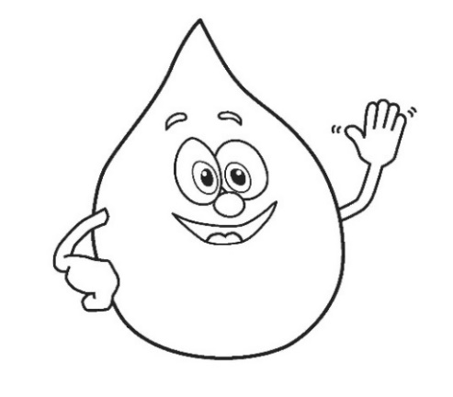
Water Scramble

Can you unscramble the words below?
(Hint: All the words are connected to water)

1. vapoationer _____ _____ _____ _____ _____ _____ _____ _____ _____ _____ _____

2. tewar _____ _____ _____ _____ _____

3. akle _____ _____ _____ _____

4. iqlidu _____ _____ _____ _____ _____ _____

5. temtnetra _____ _____ _____ _____ _____ _____ _____ _____ _____

6. tawer clyce _____ _____ _____ _____ _____ _____ _____ _____ _____ _____

7. pat tawer _____ _____ _____ _____ _____ _____ _____ _____

8. onsecrve _____ _____ _____ _____ _____ _____ _____ _____

BONUS: How many words can you make from the word TREATMENT

