Extension Activity
Activity Title: Water Story – When I Was A Child | Duration: 30 minutes
Introduction:
In this activity, students will listen to a poem written by Shirley Ida Williams nee Pheasant, and then respond to it by answering reflecting on the poem.

Shirley Ida Williams nee Pheasant is Ojibway, from Manitoulin Island, Ontario. She graduated from Trent University in 1983 with a B.A. in Native Studies. She currently is an Ojibway language professor at Trent University. She is a gifted teacher, and also an expert traditional dancer. In 2016, she was the recipient of Award for Excellence in Teaching. She is recognized as an engaging teacher who fosters a warm and inspiring learning environment for all students. This poem was written especially for this activity.

- Suitable for Grades 5 to 8
Materials:
- When I Was A Child copy of the story
Procedure:
- Read aloud the poem “When I Was A Child.” By Shirley Ida Williams nee Pheasant
- Copy of the poem is at the end of the outline
When I Was A Child - Poem
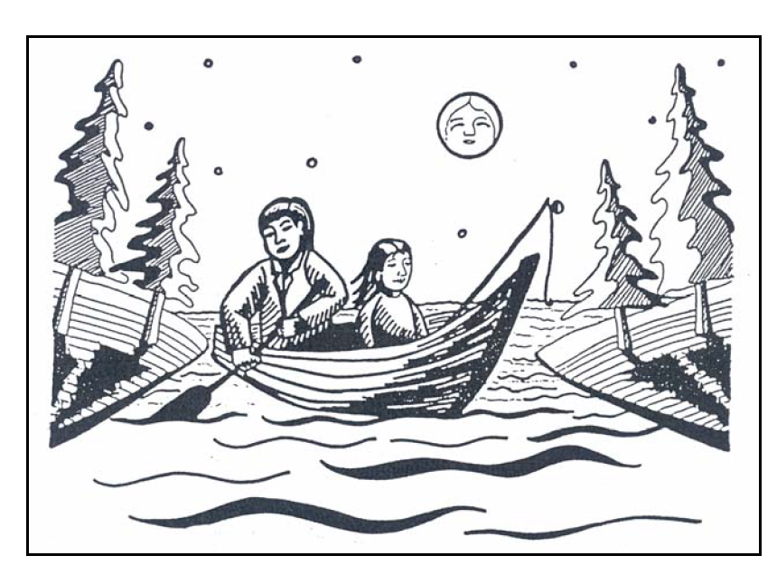
Ojibway Words:
Daw-ness-san = daughter
Paw-pa = father
Nodin = wind
Shir-o-less = Shirley
Shwan-zee-mo = John Simon
Kiisis = sun
Megwetch = Thank you
Bee-ing = water
Asin = stone
Activity Wrap-up
Ask students:
- What was the boat’s name?
- Do you think that was a good name for the boat? Why?
- Did Shir-o-lee catch any fish?
- How did her Paw-pa teach Shir-o-less? (Read carefully, to notice the most important teachings)
- Read the poem again, and Notice the four elements: water, air, fire, rock

Have the students participate by answering questions, or performing one of the following activities:
Poster: Imagine that Paw-pa is talking to you. Think of what it means to you. Make a poster, print the words, draw an illustration. Share your poster with the class. Tell why you chose that saying.

Listening Walks: Go to the woods or other natural environment. Close your eyes and listen. Write sound-words expressing what you hear. If you can’t go outside, try looking up nature apps that include animal calls.
After this exercise, try going to a built environment (machines and people), school yard in front of a street, nutrition break, write sound-words expressing what you hear.

- How do the natural sounds make you feel?
- How did the built environment sounds make you feel?

What can we do to lessen the “machines and people” built environment sounds?
- Ride a bike to school, or walk instead of driving
- Turn off screens throughout the day
- Spend time outside
- Practice mindfulness
- Start a gratitude journal – can be as simple as jotting down 1 thing you’re grateful for
- Reach out to elders in your community by writing a letter
- Go out for nature walks around your neighbourhood

Source: Adapted from Shirley Williams “When I Was A Child”.
Contents of this publication may be photocopied provided the source is acknowledged on every page by including the following Peel Water Story, Environment, Transportation and Planning Services Department, Region of Peel
When I Was A Child
When I was a child
I used to go fishing
Along with my paw-pa

He used to say to me
“Listen” Daw-niss-san!
Listen to the sounds of the boat.

Do you hear the water splashing against our boat?
And I’d say, oh yes Paw-pa

He said the wood of the boat
Is talking to the water spirit.
Ssh! Listen! They are singing together!

And when I listened
My ears became sharp
To the sounds of the outside world

The sound of the boat
Groaned and cried
For she, the Nodin (The Wind) was getting old.

Nodin creaked, squeal and squeak, sometimes rusty, her voice sometimes clear.
Her songs combined with sounds of water
Splashing against her
Made beautiful songs.

They sang and sang
About a child
Called Shir-o-less.

Shir-o-lee
I am Nodin, the wind
I will carry you
And your paw-pa, Shawn-zee-mo!

My pa used to say
Always listen!
Always be aware!
For your ears are not
For decorations!

Take a look – see the beauty of the world
Use your eyes to see the beauty. For when you see something
Only you can see it.

Only you can interpret
What you see.
Look how clear the water is.
When I looked
I saw – Beauty! Water
Shining and dancing
Before my eyes.

To see, to look,
To appreciate the beauty of things. Is a prayer.
Then, I felt good.

Beauty!
Life so precious
It’s a gift of Master.

My paw-pa used to say
Use everything you have
And always give thanks
For what you see
For some day you may not see.

In the morning always face the sun. For Kiisis
Fives heat and light.
Be sure to say
Megetch!

When night comes
Wait for the moon.
She provides night light
For us to see so we won’t get lost.

Shir-o-lee, daughter
Let us stop to fish
For we are near the rocks.

Look into bee-ing
Until you see three large rocks. For that’s our fishing mark.

Shh-hear the rocks speak
For they have spirit, too.
Whenever you are in trouble
Speak to a rock
For you have a special asin, too.

The asin we have is the
Foundation of us
For we need
A stone to stand on
For when we’re weak

Life is like sharp rocks
Full of mountains to climb.
Climb hard, my daughter,
And you will be strong.

Always, my child,
Look and listen. Use your eyes to see the world.
Breathe Nodin, the wind
For you will fee whole he said.

Then, I felt a bite on my line.
It’s a fish, I yelled.

Paw-pa smiled, then laughed so hard that I lost my line.

Let’s go home he said.
Megwetch! Nodin!
Then I heard Nodin sing.

We will go home, Shir-o-lee.
I will carry you home.

