Extension Activity

Extension Activity Title: Protecting Our Water | Duration: 20 minutes
Introduction:
Students will learn about storm sewers and where they are located in their neighbourhood. Students will learn which items can and cannot go down a storm drain, and understand the implications of disposing garbage, oil, paint and other items down the storm drain.
- Suitable for grades 4-6
Materials:
- Protecting Our Water PPT – activity for students to learn about storm sewers
- Protecting Our Water worksheet – 1 per student (optional)

Activity Set-up
- Discuss with the class the difference between sanitary sewers and storm sewers
- Play the PPT activity using the slides to learn which items belong in the storm sewers
- Optional – print the worksheet and have student match which items belong in the storm sewers

Storm Sewers: used for rain/snow collection so the streets don’t flood. Storm sewers transport rainwater and snowmelt to our rivers and creeks, and eventually to Lake Ontario. This water never goes to our wastewater treatment plant, which means that it does not get cleaned before going back to the lake
- Things that can go down the storm sewers: Rainwater, Snow Melt
- Things that cannot go down the storm sewers: Pesticides, Paint, Medications, Pet Waste, Garbage, Soapy Water, Road Salt, Oil, Pool Water
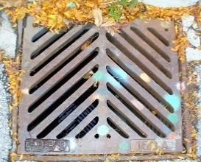

Sanitary Sewers: All water that is used in our homes and schools’ travels through a network of underground sanitary pipes to the wastewater treatment plant. These are access points for trained professionals to go down to access the pipes. If there is a blockage or a break in the pipes, they might open this up to fix it

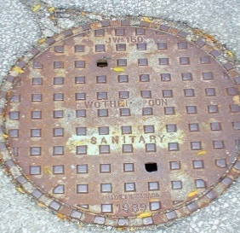

Activity Wrap-up:
Have students write a short Public Service Announcement
- Why is it important to protect our water?
- How would you teach your family about the importance of storm sewers and keeping harmful chemicals out?

Remember, we all have a responsibility to make sure dangerous materials, such as garbage and chemicals don’t go down our storm sewers and end up in Lake Ontario as it can negatively impact our environment and ultimately our health.
- Arrange to have a local park clean-up with your class, look for the storm drains near your community to clear it from any litter, debris

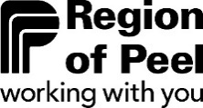
Protecting Our Water
Match the images below for proper disposal

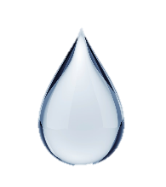
Rainwater
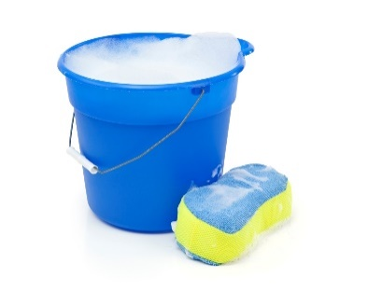
Soapy Water

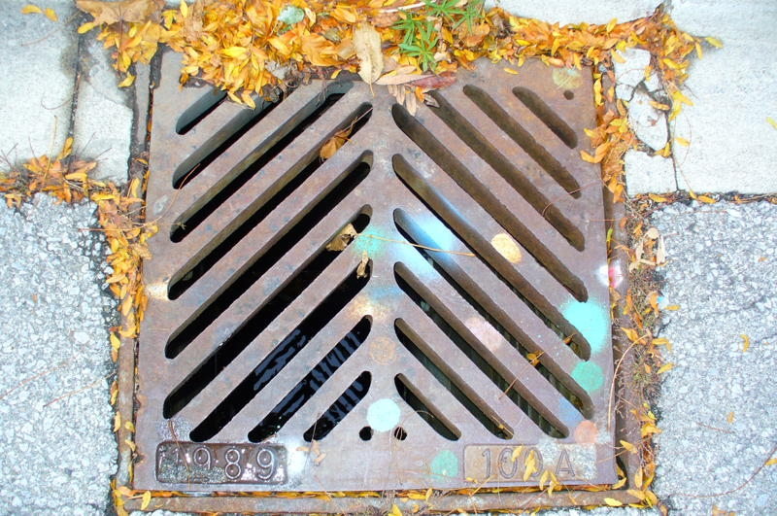

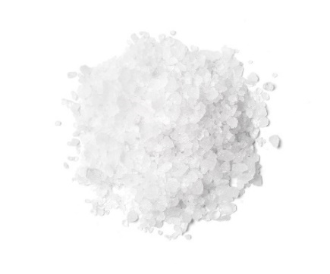
Road Salt
Medication

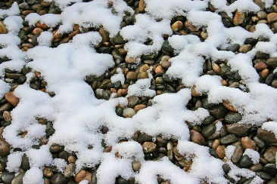
Snow melt
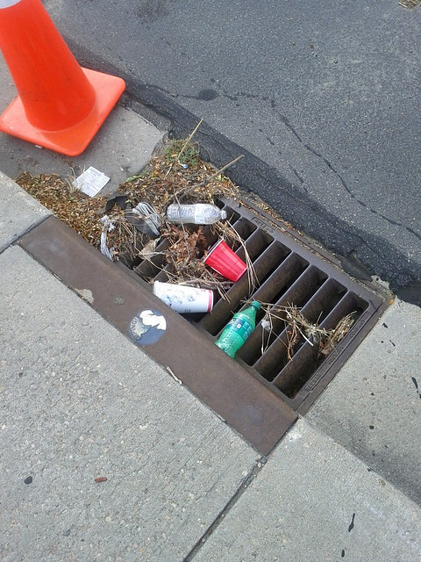
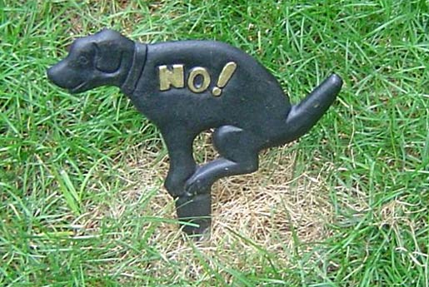
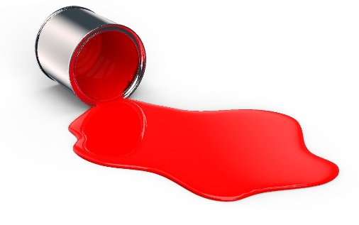
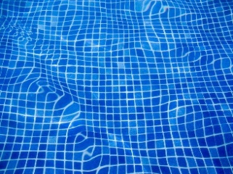
This Photo by Unknown Author is licensed under CC BY-ND
Garbage
This Photo by Unknown Author is licensed under CC BY-SA-NC
Pet Waste
Paint
Pool Water
Snow melt

