Step 1: What is the one piece of apparel that you love and is part of your permanent collection? Sunglasses? Headband? Pair of shoes? Scarf? You favourite T-Shirt? Write the name below:
MY APPAREL: __________________________________________

This item is now going to be the focus of this activity! We are now going to explore something a little more complex.

Step 2: List all the different materials that are used to make your apparel. Use the internet to research your apparel and search what your item is made from. For example, eyeglasses are made from plastic, silver, and rubber. List the brand and where they are making the clothing as well.

Step 3: Using what you’ve learned about the product lifecycle, create a lifecycle of your chosen apparel item using 10 steps. Come up with a name for each step. Make sure that each step helps connect the steps before and after:

The Life Cycle of My Apparel
1 | 2 | 3 | 4 | 5
6 | 7 | 8 | 9 | 10
Step 4: Write down an environmental impact for each step. Think about all the different materials needed in the lifecycle. Then research how you can reduce it!

The Environmental Impacts of My Apparel
1 | 2 | 3 | 4 | 5
Reduce by: | Reduce by: | Reduce by: | Reduce by: | Reduce by:
6 | 7 | 8 | 9 | 10
Reduce by: | Reduce by: | Reduce by: | Reduce by: | Reduce by:
Congratulations! You just completed a lifecycle analysis!

What are some other ways you can reduce, reuse, and recycle to create less waste? Ex. Teach your family and friends about waste management.

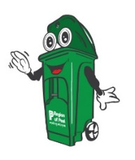
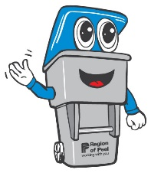
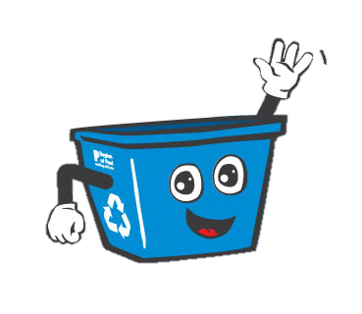
For more information about waste management, visit peelregion.ca/waste

