NOTICE OF COMPLETION
EAST TRUNK SANITARY SEWER OFFLINE STORAGE FACILITY

Study Background
Within the City of Mississauga there is a section of the East Trunk Sanitary Sewer (ETSS) (constructed in 1975, with an energy dissipation chamber (EDC) constructed in 1970), that has been abandoned for approximately nine years as a result of extensive corrosion in various locations within the sewer.
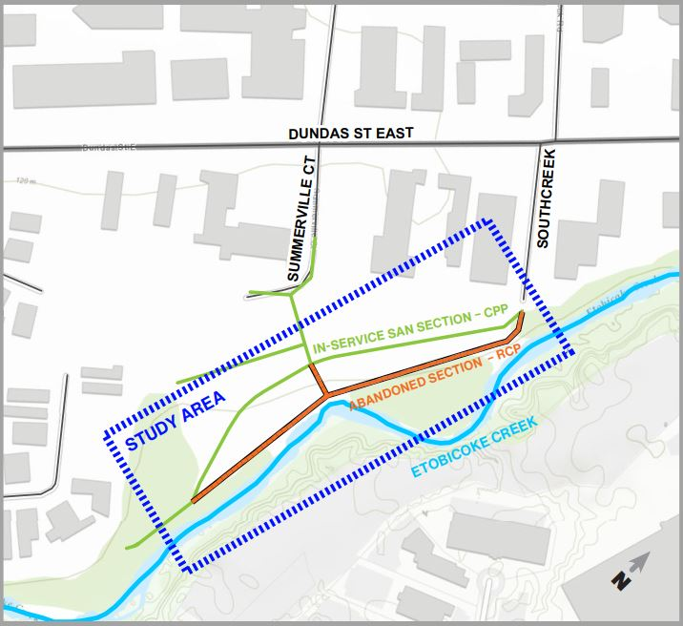
The Region of Peel has undertaken a study to identify if, and how the existing abandoned ETSS or a new offline storage facility could be used for storage of peak sanitary flows. A Schedule B Municipal Class Environmental Assessment (EA) study has been completed identifying the preferred solution. This involves the installation of an offline storage facility consisting of five parallel storage sewer pipes, replacement of the abandoned EDC and decommissioning of the abandoned ETSS.
Subject to comments received, as a result of this Notice and the receipt of necessary approvals, the Region of Peel intends to proceed to design and construction of this project.
Project File Report
The completed Project File Report will be on public record for review and comment for a 30-calendar day period. It is available electronically at peelregion.ca/public-works/environmental-assessments. We invite you to review it and provide written comments and concerns during the comment period starting September 2, 2021 and ending October 1, 2021 directly to:
Dan Bennington, C.E.T.
Project Manager, Wastewater Capital - Region of Peel
Tel. 905-791-7800 x7927
dan.bennington@peelregion.ca
Comments and Part II Order Requests
Part II Order requests may be made to the Ministry of the Environment, Conservation and Parks on the grounds that the requested order may prevent, mitigate or remedy adverse impacts on constitutionally protected Aboriginal and treaty rights. Part II Order requests on other grounds will not be considered.
Requests must be sent to the Ministry by October 1, 2021, and should be sent in writing or email to both:
Minister David Piccini Director, Environmental Assessment Branch
Ministry of the Environment, Conservation and Parks Ministry of the Environment, Conservation and Parks
777 Bay Street, 5th Floor, Toronto ON, M7A 2J3 135 St. Clair Ave. W, 1st Floor, Toronto, ON, M4V 1P5
minister.mecp@ontario.ca EABDirector@ontario.ca
Requests should specify the kind of order being requested (request for additional conditions or an individual/comprehensive environmental assessment), how an order may prevent, mitigate, or remedy potential adverse impacts, and any information in support of the statements in the request. Requests should also include the requester contact information. This will ensure that the Ministry is able to efficiently begin reviewing the request.

This notice was first issued on September 2, 2021.

The Region of Peel is committed to ensure that all Regional services, programs and facilities are inclusive and accessible for persons with disabilities. Please contact the Region of Peel Project Manager if you need any disability accommodations to provide comments or feedback for this study.

