NOTICE OF PUBLIC INFORMATION CENTRE NO. 2
Environmental Assessment and Preliminary Design for Drainage Improvements of Highway 50 from Mayfield Road to Healey Road

Background
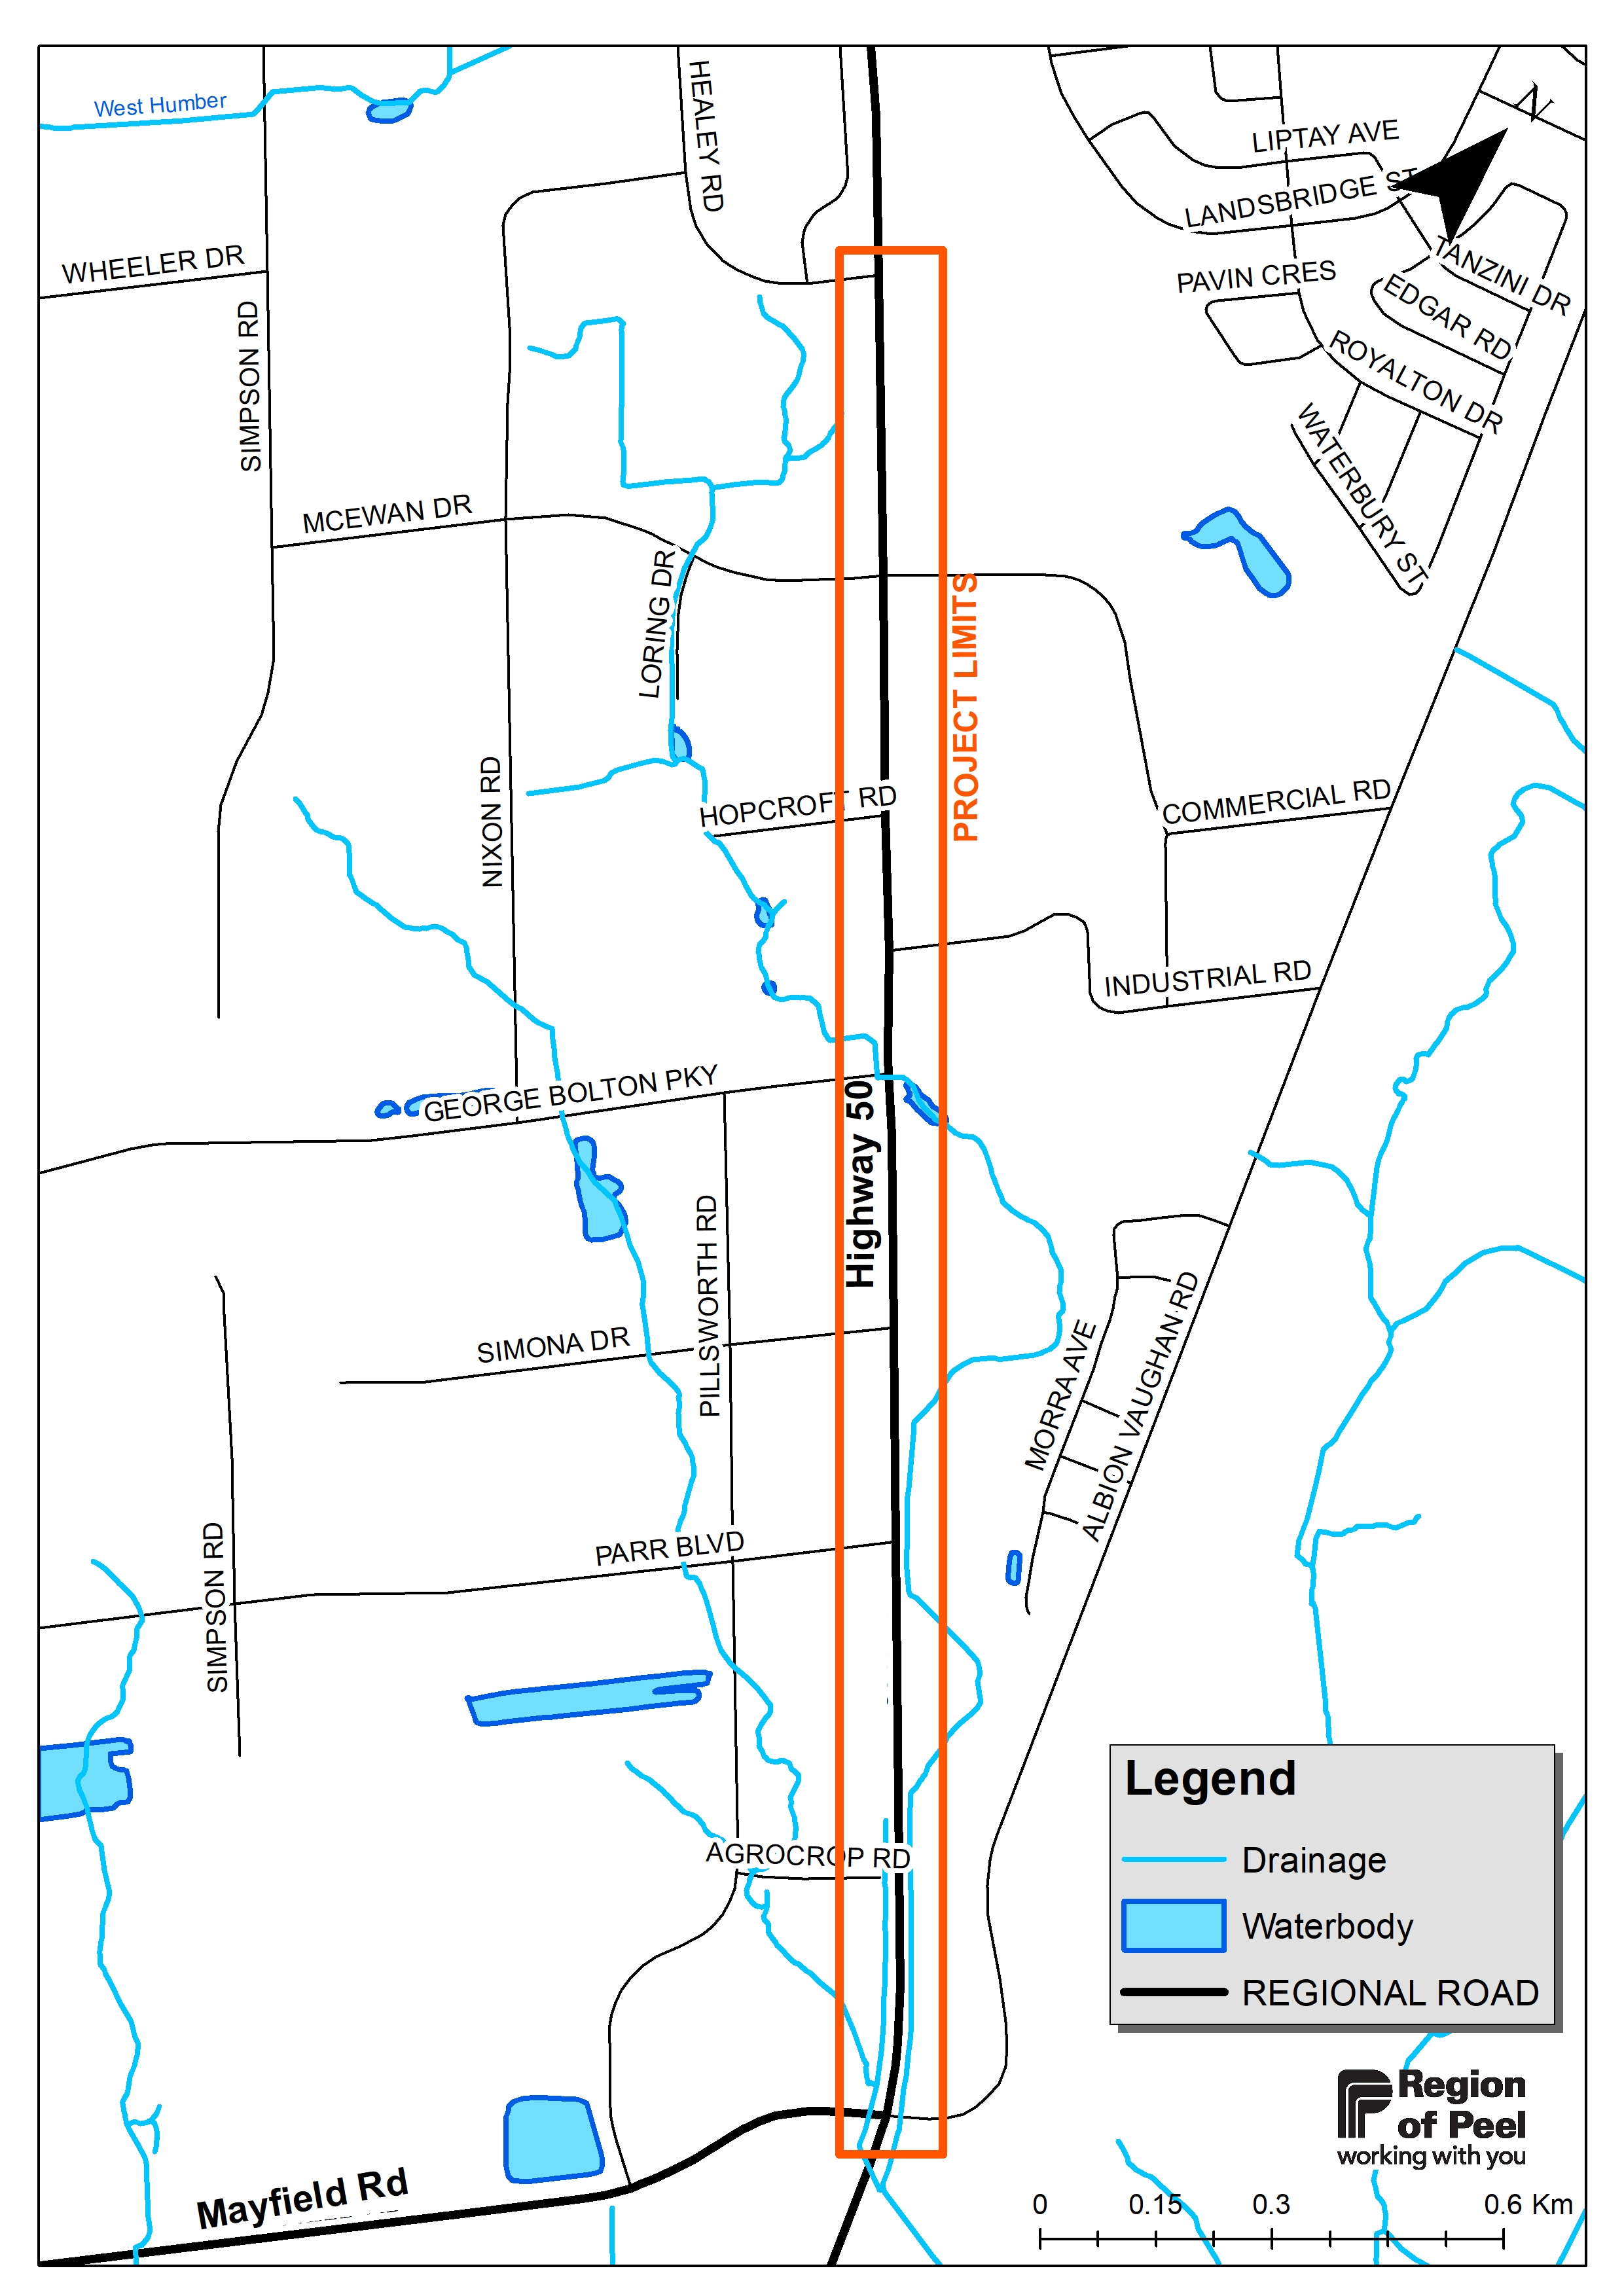
The Region of Peel is undertaking a Municipal Class Environmental Assessment (Class EA) study for the drainage improvements of Highway 50 from Mayfield Road to Healey Road, in the Town of Caledon. The culvert crossings and drainage ditches are in poor condition and require replacement to accommodate existing and future growth around the study area. The study will consider best management practices, to satisfy climate change requirements and comply with existing and future regulatory requirements. As part of the project works, active transportation improvements (i.e., pedestrian and cycling amenities) along the corridor will also be developed, in accordance with the recommendations of the Region’s Sustainable Transportation Strategy (STS).

Process
The project is being completed as a Schedule “B” project in accordance with the Municipal Class Environmental Assessment (October 2000, amended in 2007, 2011 & 2015). This notice follows as a second point of contact with the public and is outlined in Phase 2 of the process as per the requirements of the Environmental Assessment Act. As such, public and technical agency consultation will be fundamental in developing the study recommendations.

Your Input is Important
The Region wants to ensure that anyone with an interest in this study has the opportunity to be involved and provide input. Your feedback is important and will help us refine the preferred solution.

Due to COVID-19 Provincial guidelines on physical distancing, the first in-person Public Information Centre (PIC) was cancelled, however, the PIC #1 presentation materials were made available on the Region of Peel website:

https://peelregion.ca/hwy50-EA

The PIC #2 materials will be available online from March 17, 2022 and will also include a summary of the evaluation process to determine the preliminary preferred solution. All content and instructions on how to submit questions and feedback will be outlined on the project website. This will be followed by a three-week question submission period closing April 08, 2022. A formal response to all questions, comments and feedback will be posted on April 22, 2022.

Alternatively, you may also obtain a hard copy of the study information package and provide input on the study by contacting the project team members below. All comments received will be reviewed for consideration in the development of the study recommendations.

Contact
To submit your comments or if you would like more information, or to be included on the mailing list for this project, please contact one of the following members of the project team:

Region of Peel  Syeda Banuri, M.Eng., P.Eng.  Project Manager, Infrastructure Programming and Studies  416-407-7860  syeda.banuri @peelregion.ca  10 Peel Centre Drive, Suite B, Flr 4  Brampton, ON L6T 4B9 | R.V. Anderson Associates Limited  Andrew McGregor, MCIP, RPP  Senior Planner, EA & Approvals  905-685-5049  AMcGregor@rvanderson.com  43 Church Street, Suite 104  St. Catharines, ON L2R 7E1

Construction project updates can be found at peelregion.ca/construction
Follow @PeelPublicWorks on Twitter for service updates and changes.
This notice was first issued on March 10, 2022.
The Region of Peel is committed to ensure that all Regional services, programs and facilities are inclusive and accessible for persons with disabilities. Please contact the Project Manager if you need any disability accommodations to provide comments or feedback for this study.

