ENVIRONMENTAL ASSESSMENT AND PRELIMINARY DESIGN FOR DRAINAGE IMPROVEMENTS OF HIGHWAY 50 FROM MAYFIELD ROAD TO HEALEY ROAD
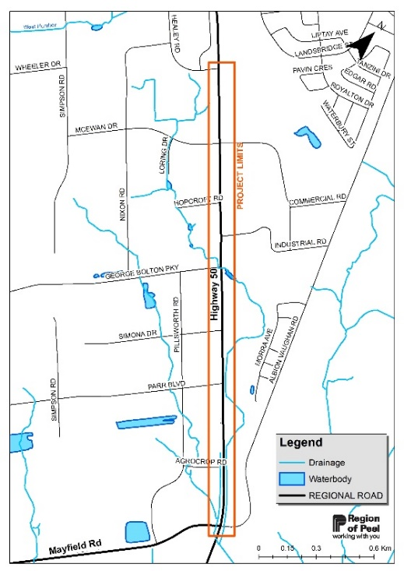
The Region of Peel has completed a Municipal Class Environmental Assessment Study for drainage improvements of Highway 50 from Mayfield Road to Healey Road, in the Town of Caledon. The project was completed as a Schedule B project in accordance with the Municipal Class Environmental Assessment (October 2000, amended in 2007, 2011 & 2015).
The study considered the need to improve drainage infrastructure in consideration of future growth, regulatory requirements, and climate change. The study also included improvements to pedestrian and cycling infrastructure, in accordance with the Region’s Sustainable Transportation Strategy.
A Project File Report documenting the planning process, study recommendations as well as potential impacts and mitigation measures is available for review on the Region’s project website at: https://peelregion.ca/hwy50-EA
If interested, you may provide written comments to the project team by January 19, 2023. All comments and concerns should be sent directly to the Project Managers listed below.
Region of Peel
Syeda Banuri, M.Eng., P.Eng.
Project Manager
Email: syeda.banuri @peelregion.ca
Tel: 416-407-7860
Peel Centre Drive, Suite B, 4th Fl.
Brampton, ON L6T 4B9
R.V. Anderson Associates Limited
Andrew McGregor, MCIP, RPP
Senior Planner, EA & Approvals
E-mail: AMcGregor@rvanderson.com
Tel: 905-685-5049 x 4211
43 Church Street, Suite 104
St Catharines, ON L2R 7E1
In addition, a request may be made to the Ministry of the Environment, Conservation and Parks for an order requiring a higher level of study (i.e., requiring an individual/comprehensive EA approval before being able to proceed), or that conditions be imposed (e.g. require further studies), only on the grounds that the requested order may prevent, mitigate or remedy adverse impacts on constitutionally protected Aboriginal and treaty rights. Requests on other grounds will not be considered. Requests should include the requester contact information and full name for the ministry.
Requests should specify what kind of order is being requested (request for additional conditions or a request for an individual/comprehensive environmental assessment), how an order may prevent, mitigate, or remedy those potential adverse impacts, and any information in support of the statements in the request. This will ensure that the ministry is able to efficiently begin reviewing the request. Please send requests in writing or by email to:
Hon. David Piccini, Minister
Ministry of Environment, Conservation and Parks
777 Bay Street, 5th Floor, Toronto ON M7A 2J3
minister.mecp@ontario.ca
Director, Environmental Assessment Branch
Ministry of Environment, Conservation and Parks
135 St. Clair Ave. W, 1st Floor, Toronto ON, M4V 1P5
EABDirector@ontario.ca

The Region of Peel is committed to ensure that all Regional services, programs, and facilities are inclusive and accessible for persons with disabilities. Please contact the Project Manager if you need any disability accommodations to provide comments or feedback for this study.
This notice was first issued on December 1, 2022

