NOTICE OF STUDY COMPLETION - SCHEDULE B
Claredale Road to Beechwood Pumping Station

The Study:
Figure A-1: Claredale EA: Area of Focus Map
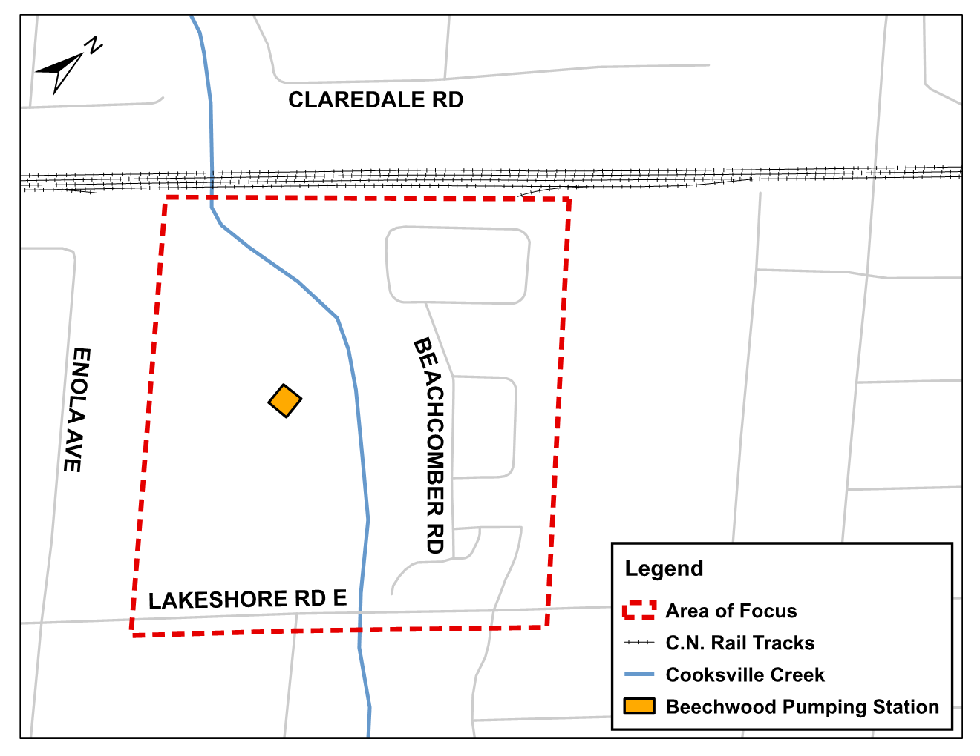
The Region of Peel has identified the need to replace the siphon under Cooksville Creek, which will involve redirecting wastewater flows from the Claredale Road area to the Beechwood Pumping Station. The preferred solution includes construction of a new sewer which connects to existing maintenance hole south of the C.N. Rail Tracks and crosses under Cooksville Creek, discharging into Beechwood Pumping Station. Figure A-1 shows the area that may be directly impacted by the proposed construction.
The Claredale Road to Beechwood Pumping Station project is being planned under Schedule B of the Municipal Class Environmental Assessment. Subject to comments received as a result of this Notice, and the receipt of necessary approvals, the Region of Peel intends to proceed with the design and construction of this project.
Project materials and other information are available at peelregion.ca/public-works/environmental-assessments.
Contact:
To provide comments or request additional information about this project, please contact:
Lyle LeDrew
Project Manager, Water & Wastewater
905-791-7800 ext. 7836
Lyle.ledrew@peelregion.ca
For concerns that involve the prevention, mitigation or remediation of adverse impacts on constitutionally protected Aboriginal and treaty rights, a Part II order request may be made to the Ministry of the Environment, Conservation and Parks. Part II order requests on other grounds will not be considered.
Requests should specify what kind of order is being requested (request for additional conditions or a request for an individual/comprehensive environmental assessment), how an order may prevent, mitigate or remedy those potential adverse impacts, and any information in support of the statements in the request. Requests should also include the requester contact information. This will ensure that the Ministry is able to efficiently begin reviewing the request.
Requests must be sent by March 31, 2021. Requests should be sent in writing or by email to both:
Minister of the Environment, Conservation and Parks  Ministry of Environment, Conservation and Parks  777 Bay Street, 5th Floor  Toronto ON M7A 2J3  minister.mecp@ontario.ca | Director, Environmental Assessment Branch  Ministry of Environment, Conservation and Parks  135 St. Clair Ave. W, 1st Floor  Toronto ON, M4V 1P5  EABDirector@ontario.ca  This Notice was first issued on February 25, 2021.
The Region of Peel is committed to ensure that all Regional services, programs and facilities are inclusive and accessible for persons with disabilities. Please contact the Region of Peel Project Manager if you need any disability accommodations to provide comments or feedback for this study.

