Step 1: You are entering a scavenger hunt! Find 5 items in your house that you would throw away daily.
Step 2: Now, imagine that you no longer need these items and that you have thrown them into the garbage. Everything we throw into the garbage goes to a landfill. Research how long each item would take to completely decompose in a landfill. In the boxes below write your item and how many years it would take for it to fully decompose.
Item
Number of years to Decompose

If you’re stuck on what landfill and decompose mean, here is some help:
Landfill: a system of garbage and trash disposal in which waste is buried between layers of earth
Decompose: to break down or be broken down into simpler parts or substances especially by the action of living things (as bacteria and fungi)
Step 3: Now that you know how long your items would take to decompose in a landfill, create a timeline starting from the least amount of time to decompose to the longest amount of time to decompose. Draw your items in the boxes and use the years for each item in the boxes above to construct your timeline.
Step 4: Each of your items will take a long time to decompose in a landfill, but did they all have to be thrown out in the garbage? Could they have been thrown in the recycling, organics, or a Community Recycling Centre?
Longest amount of time
Least amount of time
Sort your waste! Write the items in each box and then draw a line to which bin you think your item should end up in!

Garbage
Organics
Recycling
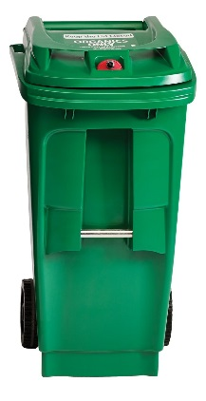
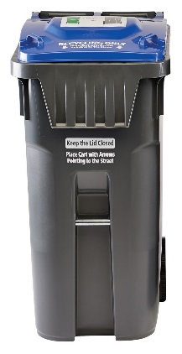
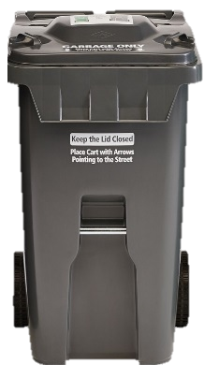
Community Recycling Centre

Visit peelregion.ca/waste to check if you sorted the items correctly.

